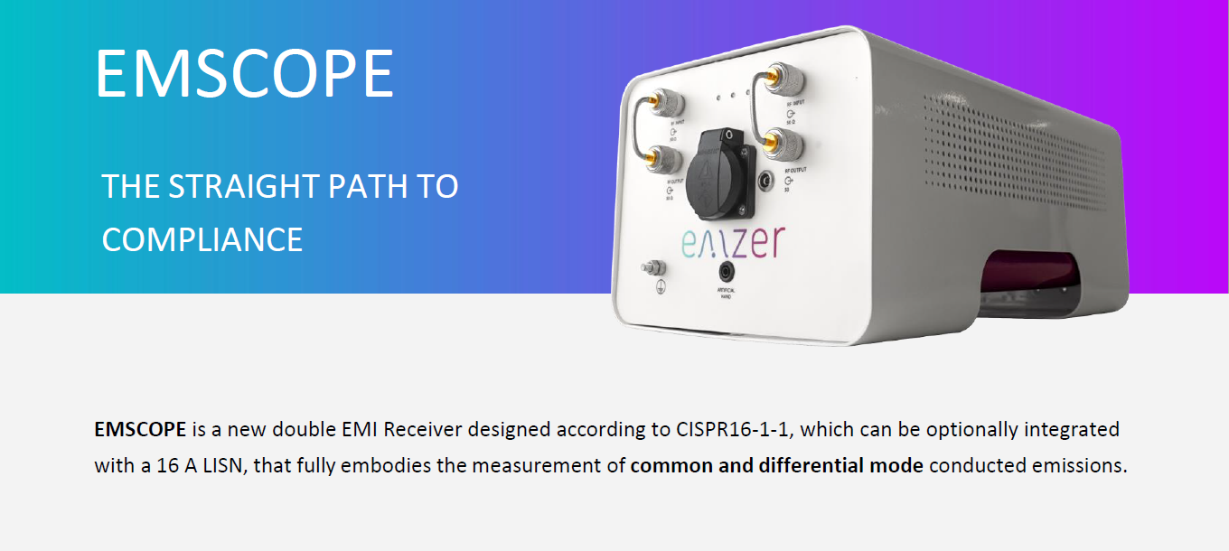
EMSCOPE is a polyvalent, powerful and fast tool that performs full-band real-time EMI and modal measurements simultaneously using peak, quasi-peak, and average detectors from 9 kHz to 110 MHz.
Obtaining instantaneous measurements of common and differential mode emissions allows R&D engineers to find the dominant mode at each frequency band and to design and implement the optimal power line filter (PLF) for a given device under test (DUT).
EMSCOPE includes innovative solutions and features, speeds up your time-to-market at a reduced cost, and offers added value to its users when compared to any other commercial EMI receiver.
This note aims to illustrate a summary of the advanced features and benefits of the EMSCOPE, the innovative Dual FFT-Modal EMI Receiver designed and manufactured by EMZER.
EMSCOPE performs EMI conducted emissions testing. It is the only receiver in the market able to simultaneously measure two channels according to CISPR16-1-1.
Peak, quasi-peak and average detectors can be run in parallel and real time with the specified resolution bandwidths (RBWs) of 200 Hz, 9 kHz, 120 kHz (CISPR) and 1 kHz, 10 kHz (MIL).
- Allows EMC testing to verify EUT’s compliance throughout the whole development phase.
One of the most innovative features is the capability to simultaneously measure the common and differential mode interference emitted by the DUT.
The noise decomposition is a key troubleshooting step that helps engineers to locate the dominant mode at relevant frequencies and, with it, to design a specific and optimal power-line filter for the DUT in a straightforward way. Check our web for effective examples, application notes and more.
- It allows to implement the best EMI power-line filter for your DUT.
- It reduces the testing time, and therefore, the designing costs.
EMSCOPE is a Dual Channel Receiver able to simultaneously measure two channels, Line and Neutral, and with all three detectors activated at the same time.
Besides, thanks to the FFT properties, the whole spectra is measured in a single dwell time. That means that every second (as an example of configuration), EMSCOPE is able to show up to six different measurements (Line, Neutral with the three detectors for each one) in a continuous way.
Any other commercial EMI receiver cannot achieve such amazing performance.
- Fastest EMI Receiver in the market for conducted emissions.
- First and only double channel receiver available in the market.
This feature shows the conducted emissions in a three-dimension figure: the vertical and horizontal axis represent the time evolution and the frequency respectively, and the third dimension, represented with a color scale, contains the amplitude of the measured signal. This function has additionally been smartly enhanced to make the detection of conducted-emission problems easier. The user can monitor any DUT for up to 600 sweeps and can recover any of these slices for analysis and comparison purposes with, for instance, a standard limit. It can also be applied to common and differential-mode measurements.
Therefore, even DUTs presenting different modes of operations can be completely characterized, and its worst-case mode can be easily analyzed and solved. Check our web for effective examples, application notes and more.
- Any interference coming from EUT is also represented in Time-Frequency domain.
- Easy to detect the worst functional mode for faster and more accurate measurements.
In order to obtain more information about the interference nature, the instrument incorporates a full oscilloscope mode that provides the waveform voltage measurements in time domain.
The configuration functions include the trigger control, sampling speed, amplitude level and cursor position, among others.
- Understand better the DUT interference behavior: detect, analyze, and solve.
EMSCOPE integrates a 16-A single-phase dual-port V-network Line Impedance Stabilization Network (LISN) and two Transient Limiter (5W), becoming the most compact solution available in the market.
Anyway, thanks to its external connectors, it can also be connected to external LISNs using either one or the two receiver ports, when considering different applications, as automotive, military, or for DUTs that require higher current levels.
- Maximum flexibility for specific needs, like automotive applications.
- Internal 16 A LISN is optional – additional cost reduction.
The instrument is really easy to install, connect and use. The necessary software to run an EMSCOPE is completely integrated inside, and there is no need of additional installations or configurations. EMSCOPE can be connected either to an office LAN or directly to a PC, using the supplied optical fiber (which avoids the coupling of external interference to the measurements) and the fiber to Ethernet converter. The user only needs to open a web browser and write the EMSCOPE domain address, and a friendly web-based application is directly opened to operate and control it. Free updates are provided regularly.
The software offers different functions to analyze the measurements, provides automatic reporting (editable pdf reports can be downloaded) and allows to save the measurements and share them with any other computer (since stored measurements are opened using any web-browser and no other software is required), among other functions.
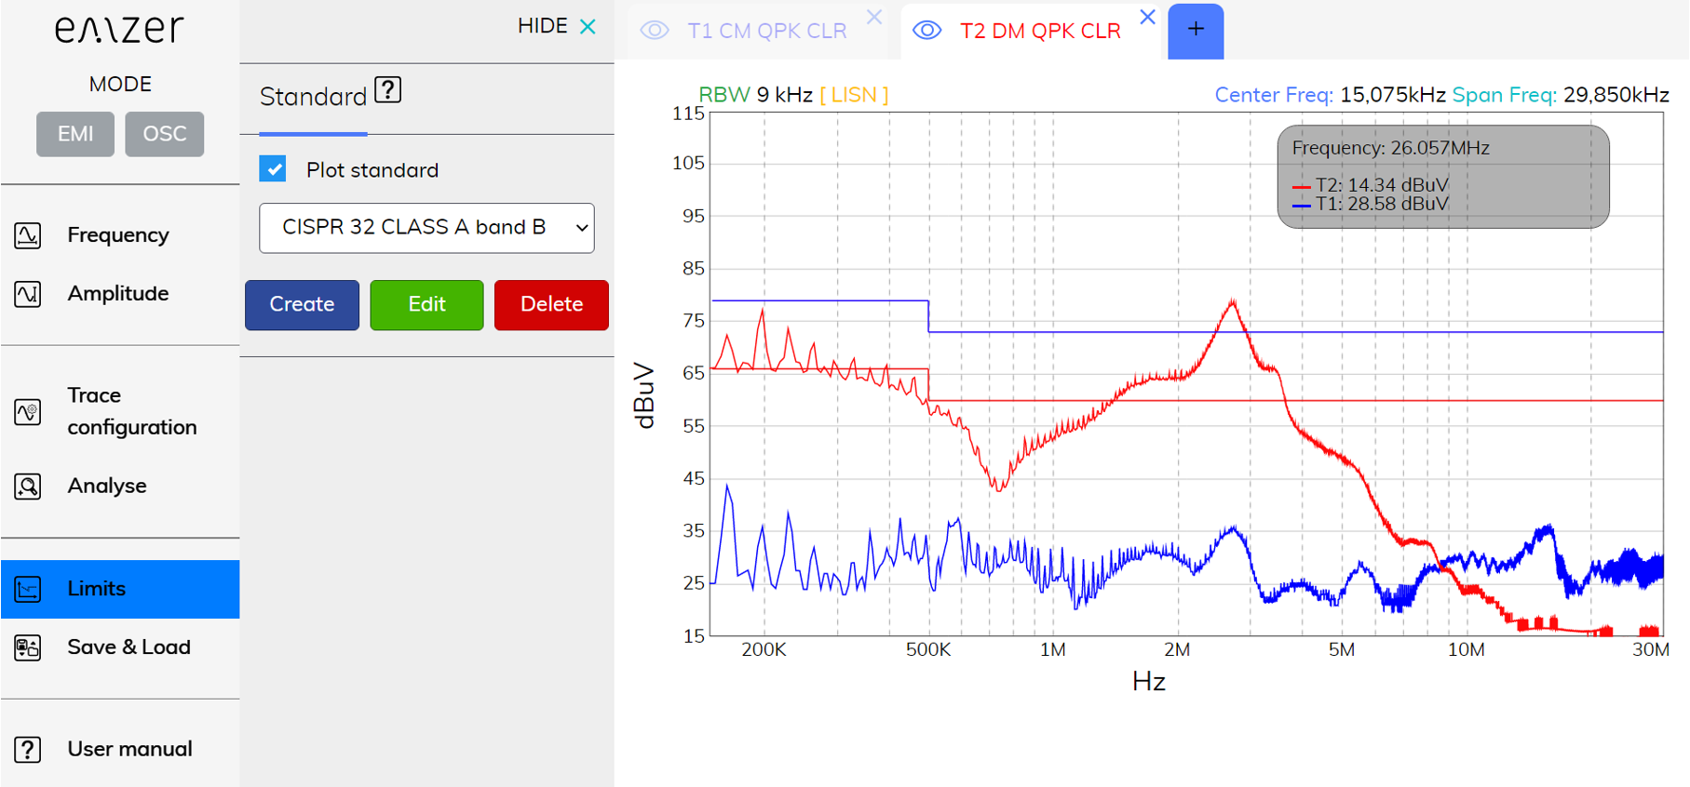
- No previous experience is needed to use the EMSCOPE software.
- Free updates and support.
Last but not least, since the whole measurement setup of a standard conducted-emission test is integrated inside the EMSCOPE: two-channel receivers, two-channel single phase LISN, two transient limiters and the software, it becomes a very cost-effective instrument, much more affordable than buying each of these components individually.
- Compact solution for easy relocation inside the laboratory, or for on-site testing.
- Flexible and easy to use.


