EMSCOPE
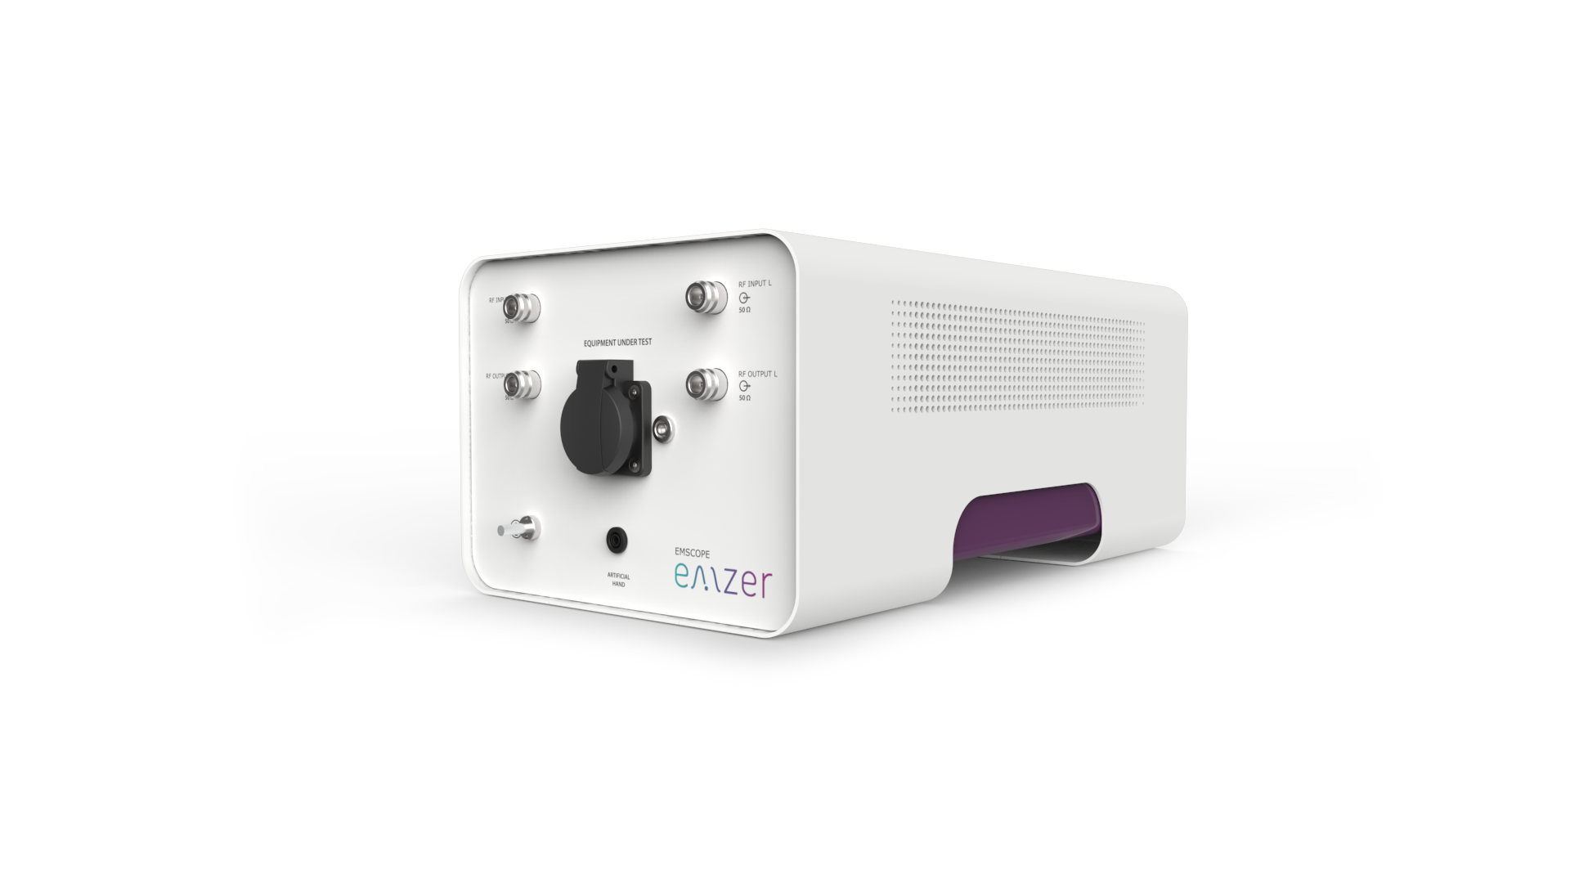emscope.png
List of resources for EMSCOPE devices
Wiki | PDF | Description
User Manual |  | EMSCOPE's User Manual
WebSocket API |  | A document describing how to open a WebSocket connection to control and monitor the device
Javascript API |  | An implementation of the API in JavaScript and examples on how to use it
Python API |  | An implementation of the API in Python and examples on how to use it
LICENSES |  | A list of software and libraries used by the device and their licenses
* Updates for devices can be found in the updates for EMZER devices page.

