EMSCOPE User’s Manual

1. General Information

1.1 Documentation
Enclosed with this manual are:
- a service questionnaire to send back to EMZER in case an equipment service is needed (end).
- an accessories checklist to verify all accessories enclosed in the packaging.

1.2 Introduction to EMSCOPE
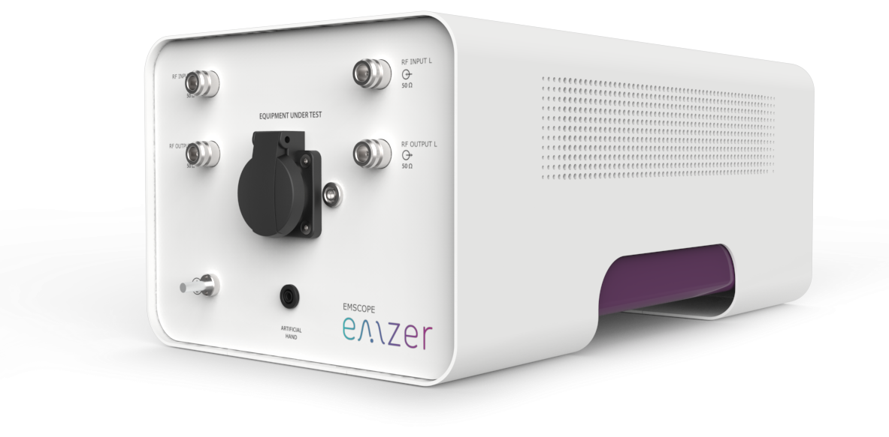
Figure 1. EMSCOPE picture.
EMSCOPE is an EMZER’s instrument for ElectroMagnetic Interference (EMI) measurements that combines a 2-channel EMI-Test Receiver with a 16-A single-phase dual-port V-network Line Impedance Stabilization Network (LISN) and two Transient Limiters (one for each channel of the EMI receiver). EMSCOPE has been optimally designed and manufactured to be compliant to CISPR 16-1-1, CISPR 16-1-2 and MIL-STD-461E International Standards for measurements of conducted electromagnetic interference from 9 kHz up to 110 MHz.
EMSCOPE integrates the peak, quasi-peak and average detectors compliant to CISPR 16-1-1, which can be run in parallel and real time, considerably reducing the measurement time when compared to any other option. Additionally, it is possible to simultaneously measure the line and neutral emissions, or the common-mode and differential-mode (modal) emissions with the three detectors running simultaneously. Modal-emission measurements are fundamental to know the dominant mode and to implement the suitable power-line filter accordingly, using fewer components and getting a cheaper design.
EMSCOPE can be connected to a LAN or reached by direct connection (using the supplied optical fibre), and it is remotely controlled using any standard web browser, without the necessity of any additional software. The web-based application installed in EMSCOPE exhibits a very friendly and intuitive interface that makes any kind of measurement really easy to be configured.
Important! Before using the LISN, all safety requirements must be fulfilled.

1.3 Instrument Items
EMSCOPE includes the following items:
- EMSCOPE enclosure containing two EMI-Test Receivers, a 16-A single-phase dual-port V-network LISN and two Transient Limiters.
- Tp link multimode fiber to Ethernet converter.
- IEC 20 cable.
- IEC 14 Cable.
- SFP Multi-mode optical fiber 50 or 62.5/ 125 LC LC connector (standard 1000BASE-SX). W. length: 850nm.
- Operating Manual.
- Certificate of Calibration.
- Return for Repair form.

1.4 Optional accessories
Additionally to the multi-mode fiber to Ethernet converter, EMZER can supply a multi-mode fiber to USB converter to directly connect the computer to the EMSCOPE. The model supplied is:
- DIGITUS USB 3.0 Gigabit SFP Network Adapter (Digitus DN-3026) with a fber optics transceiver (Digitus DN-81000).
Important! It is highly recommended to use this option with a USB-3.0 port.

1.5 Other accessories
EMSCOPE can be used with:
- External LISNs of any type
- Near Field Probes
- Current probes

1.6 Main Specifications
Table 1-1 lists the EMSCOPE performance specifications. The following conditions apply to all specifications:
Table 1-1 Main Specifications of the EMI Receiver
Electrical Characteristic | Performance Limits
Frequency range / RBW Filter  Resolution / RBW Filter  Frequency accuracy | 9 kHz to 150 kHz / 200 Hz  9 kHz to 150 kHz / 1 kHz  150 kHz to 30 MHz / 9 kHz  150 kHz to 30 MHz / 10 kHz  30 MHz to 110 MHz / 120kHz  113 Hz / 200Hz  509 Hz / 1kHz  5087 Hz / 9kHz  5087 Hz / 10kHz  30.52 kHz / 120kHz  ≤ 2.5 ppm @operating temperature range  = 1.5 ppm @ 25ºC
RF inputs  VSWR  Attenuator  Transient limiter | ZIN 50 Ω, N fem.  < 1,2  0 dB to 78 dB (1 dB step)  Built in up to 30 MHz.  1dB compression point: 23dBm
Max input level (without equipment damage) | 144 dBμV (5W, 37 dBm)
Noise level (Att. 22 dB, 50 Ω term., Hold Time 1 s)  9kHz to 150kHz  (200Hz RBW)  9kHz to 150kHz  (1kHz RBW)  150kHz to 30MHz  (9kHz RBW)  150kHz to 30MHz  (10kHz RBW)  30MHz to 110MHz  (120kHz RBW) | < -9 dBμV (QP)  < -15 dBμV (AV)  Not defined (QP)  < -13 dBμV (AV)  < 7 dBμV (QP)  < 0 dBμV (AV)  Not defined (QP)  3 dBμV (AV)  < 27 dBμV (QP)  < 15 dBμV (AV)
Detectors | Peak, Quasi-peak, CISPR Average (all can be run simultaneously on both lines, that is, up to 6 detectors)
Type of measurements | Physical (or circuit, i.e. line and neutral) and modal (common and differential mode) conducted emissions
Full spectrum measurement time | Equal to the measurement dwell time, which is totally configurable from 1s to 15s
Display units | dBm, dBmV, dBµV, Watts, Volts
Measurement accuracy for sinusoidal signals > 20 dB | 9 kHz to 150 kHz / 200 Hz ± 1,5 dB  9 kHz to 150 kHz / 1 kHz ± 1,5 dB  150 kHz to 30 MHz / 9 kHz ± 1,5 dB  150 kHz to 30 MHz / 10 kHz ± 1,5 dB  30 MHz to 110 MHz / 120 kHz ± 1,5 dB
CISPR 16-1-1 conformity | Standard compliant QP detector down to 1 Hz PRF for bands A and B. Down to 10 Hz PRF for band C.  Standard compliant Average detector down to 1 Hz PRF for bands A and B. Down to 10 Hz PRF for band C.
I/O Interface | SFP Optical
Operating temperature | 0 °C to 40 °C
Power supply | 110-240 VAC. Consumption: 25W max
Dimensions (W x H x D) | 252 x 195 x 438 mm
Weight | 8.5 kg
Built in LISN | Fully compliant to CISPR 16-1-2 standard
Frequency range | 9 kHz to 30 MHz
Continuous rated output current | Up to 16 A @ 230 VAC (socket dependent)*
Max permissible operating voltage | Up to 300 VAC – 325 VDC (socket dependent)*
EUT supply frequency range | DC to 60 Hz
CISPR equivalent circuit / Pre-filter Choke | 50 Ω / / (50 μH + 5 Ω) / 250 μH
EUT Power connector / mains | Schuko socket (Type F) / IEC C20
Artificial Hand / connector type | 510 Ω + 220 pF / 4 mm socket
* Examples of sockets: *See notes:
- NEMA 5-15R: 15A / 125Vac
- EU Type F: 16A / 230Vac
- GB BS1363 Type G: 13A / 250Vac
Notes:
- The LISN and all of its components can handle 300V, 16 amps.
- Full compliance with CISPR 16-1-1 has been achieved by accrediting the detectors using the pulsed-tone method in an accredited laboratory. Any customer wishing to accredit the receiver down to 1 Hz must do so in an EMC laboratory that follows this same method.

1.7 Front Panel
The front panel of the EMSCOPE is shown in the next figure.
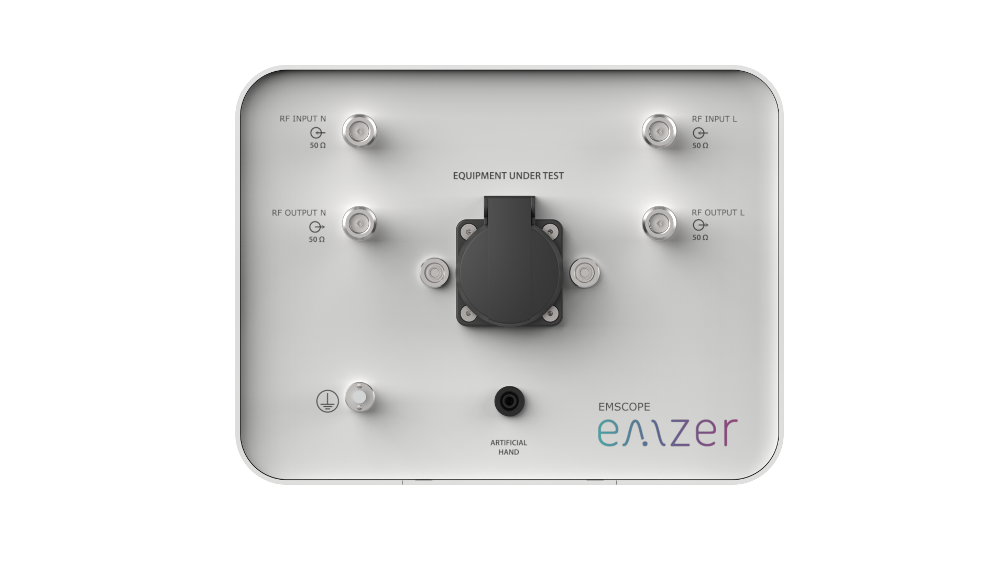
Figure 2. Front panel.
Connectors and indicators of the front panel from top to bottom:
- LEDs
- RF input 50 Ω connectors
The equipment has 2 N female RF input 50 Ω connectors that permits the equipment to simultaneously measure 2 RF signals. Each RF input is internally protected from transient voltages by means of a transient limiter. The technical characteristics are described in the Main Specifications section.
- RF output connectors
The equipment has 2 N female RF output connectors. Each connector is the output of a channel of the artificial mains network (LISN). These connectors output the conducted interferences generated by the equipment under test and provide the means to measure them.
- Output mains power network supply socket
This socket is the output of the artificial mains power network of the LISN. It is the mains socket where the equipment under test must be connected to allow the measurement of its conducted emissions. The technical specifications of the LISN and its power handling capabilities are described under the Main specifications section.
- Artificial Hand 4mm socket
This socket provides the RC network required to mimic the behaviour of a hand for a handheld equipment under test, as stated in the CISPR 16-1-2. This RC network is described in the Main Specifications section.
- Protective earth terminal. It is a M6 threaded bolt for connecting the protective earth conductor.
- Additionally, there exist two 4mm female sockets for connecting the reference ground during calibration.

1.8 Rear Panel
The rear panel of the equipment is shown in the next figure:
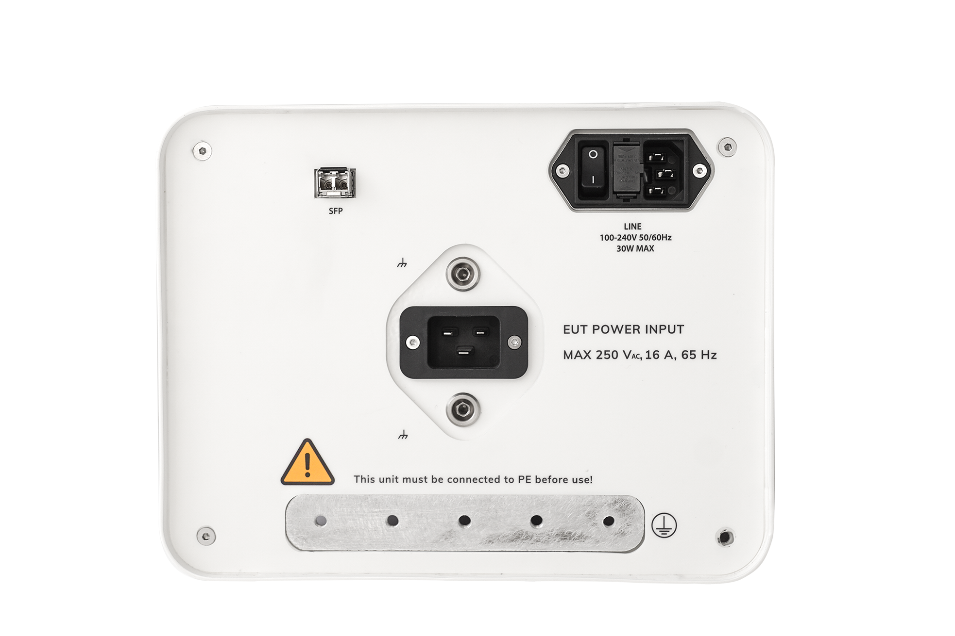
Figure 3. Rear panel.
Connectors of the rear panel from top to bottom:
- SFP connector. The installed SFP transceiver is described in the Instruments Items section.
- Instrument power supply socket. It includes fuses and the On-Off switch.
- IEC-20 socket. It is the socket of the mains power supply that cross the LISN and feeds device under test.
- Grounding bar. This bar provides an appropriate RF ground reference and it should be connected to the grounded RF plane as described in different standards (e.g. CISPR 16-2-1).
- Additionally, there exist two 4mm female sockets for connecting the reference ground during calibration.

1.9 EMSCOPE Overview
The EMSCOPE features a completely new receiver architecture based on the most recent FPGA technology that includes a two port CISPR 16-1-2 LISN and two 10-dB transient limiters, and has been designed to be controlled using only a web browser, independently of the operating system and platform. No additional software is required.
In the CISPR bands A (9 kHz ÷ 150 kHz), B (150 kHz ÷ 30 MHz) and C (30 MHz ÷ 110 MHz) the standards require the use of specially shaped 200-Hz, 9-kHz and 120-kHz filters respectively (1-kHz and 10-kHz filters in the MIL-standard case). EMSCOPE makes use of internal numerically modelled filters in compliance with the norms, using FFT and signal processing techniques, which allows to perform measurements according to both standards (CISPR and MIL). Besides, it can provide simultaneous and real-time measurement results using the peak, quasi-peak and average detectors in compliance with CISPR-16-1-1 .
The fully-compliant-to-16-1-2-standard LISN integrated in the instrument allows performing conducted-emission measurements without the necessity of any other device, making of EMSCOPE a Fully Measurement Setup. Additionally, it can also be easily connected to other external LISNs, using its external N connectors, to perform EMI measurements according to any other standard. Thanks to its architecture and to the large internal computation capability, the EMSCOPE can perform a precise entire band test in an extremely short time. This feature is not only useful to greatly increase the productivity of the test lab, but also to make better and more comprehensive analysis in case the disturbance to be evaluated is somehow intermittent and with an irregular repetition rate. Since it is possible to perform a modal analysis of the interference, providing the common-mode and differential-mode measurements, it is really easy to design a suitable power-line filter for the EUT.
Additionally, EMSCOPE incorporates an oscilloscope mode to visualize the conducted emissions in time-domain, providing more information about the connected EUT.

2. Safety information

2.1 General safety information
Never remove the cover or any part of the housing. During operation, there exists accessible parts with DANGEROUS voltages inside the unit.
Do not insert any objects into the openings of the housing that are not intended to that purpose. This can cause short circuits inside or electric shocks/injuries.
The unit is not protected against the penetration of liquids. Do not close any of the openings needed for ventilation.
Since the ventilation air flows from the bottom side, the unit must be placed on a non-flammable base in order to prevent a fire in case of overheating.

2.2 Safety information regarding the Line Impedance Stabilization Network (LISN)
In addition, due to this high leakage current (above 1 A), it is not possible to use a residual current operated circuit breaker. It is strongly recommended to use an isolating transformer.
Important! Earth connection: Precautions must be taken because, since the LISN is compliant to CISPR 16, it cannot inherently adhere to the permitted leakage current limit value according to EN 61010-1 and basic insulation of a protection class I. Due to this inherent high leakage current to ground of this kind of equipment an additional protective earth connection must be supplied prior connecting the unit to the mains power supply. For this purpose, the equipment is provided with an earth grounding bar at the rear panel and additionally a protective earth screw is provided at the front.
Important! Before putting into service ensure that:
- An additional PE conductor is connected (see next paragraph).
- The ventilation openings are unobstructed.
Important! Over current protection is not provided. The LISN must be connected to a power mains which has an appropriately rated mains protection installed.
A long-term operation with maximum load, the surface of the unit may become >60 ºC.

3. Installation

3.1 Introduction
This section provides the information needed to install your EMSCOPE. It includes the information pertinent to initial inspection and power requirements, connections, operating environment, instrument mounting, cleaning, storage and shipment.
Important! Before connecting the equipment follow the provided Safety information section. Not following it can result in important damages, serious injuries and death.

3.2 Initial Inspection
When receiving the equipment, first inspect the shipping box for any damages. If the shipping box is damaged, it should be kept until the contents of the shipment have been checked for completeness and the instrument has been checked mechanically and electrically.

3.3 Packing and Unpacking
Verify the availability of all the shipped items with reference to the shipping check list enclosed with the User Manual. Notify any damage to the forwarder personnel as well as to your EMZER Representative.
To avoid further damage, do not turn on the instrument when there are signs of shipping damage to any portion of it.

3.4 Preparation for Use
The EMSCOPE EMI Receiver is a Safety Class I apparatus, and it is also equipped with protective/functional earth terminals on the rear and front panels. A good safety/functional ground connection should be provided before to operating the system.
Important! The EMSCOPE LISN constructed according to the standard CISPR 16 can NOT comply with the permissible leakage current limit stated in the IEC 61010 for a class I equipment. The instructions provided in the Safety Information section must be followed.

3.5 Power Supply
The universal adapter supplied with the receiver can work at either 50 Hz or 60 Hz with a supply voltage rated between 100 and 240 Volt. When the power supply is switched ON, the green led lights up. After about 45 seconds (depending on the network status) since the power has been switched on, the EMSCOPE is ready for use.

3.6 Front Panel LEDs
The front panel of the EMSCOPE has three LEDs, which provide some information to the user:
- The leftmost green LED is switched on when the EMSCOPE is powered on.
- The middle yellow LED blinks according to the network activity.
- The rightmost LED is fixed green and switches on when the EMSCOPE is ready to operate. It switches to purple when a user connects, and returns to green when the user disconnects.

3.7 Environment
The operating environment of the receiver is specified to be within the following limits:
- Temperature : 0 °C to +40 °C
- Humidity : < 85% relative LISN; < 95% relative EMI receivers
- Altitude : 3000 meters
The instrument should be stored and shipped in a clean, dry environment which is specified to be within the following limitations:
- Temperature : -40 °C to +50 °C (-40 °C to +40 °C for long periods)
- Humidity : < 95% relative (< 80% relative for long periods)
- Altitude : 15000 meters

3.8 Return for Service
If the instrument should be returned to EMZER for service, please complete the service questionnaire enclosed with the User Manual and attach it to the instrument.
To minimize the repair time, be as specific as possible when describing the failure. If the failure only occurs under certain conditions, explain how to duplicate the failure.
If possible, reusing of the original packaging to ship the equipment is preferable.
In case other package should be used, ensure to wrap the instrument in heavy paper or plastic.
Use a strong shipping box and use enough shock absorbing material all around the equipment to provide a firm cushion and prevent movement in the shipping box; in particular protect the front panel.
Seal the shipping box securely.
Mark the shipping box FRAGILE to encourage careful handling.

3.9 Equipment Cleaning
Use a clean, dry, non-abrasive cloth for external cleaning of the equipment.
To clean the equipment do not use any solvent, thinner, turpentine, acid, acetone or similar matter to avoid damage to external plastic or display surfaces.

3.10 Equipment Ventilation
To allow correct equipment ventilation, ensure that the vent grids on the side and on the bottom of the equipment are free by any obstructing object.

3.11 Hardware Installation
EMSCOPE is delivered from factory ready to use. After removing the instrument from its cardboard shipping box, the user must perform the following connections before switching it on:
- Connect EMSCOPE to the suitable networking technology. To this end, connect a multimode fibre from the EMSCOPE’s SFP port to the SFP port of the user’s media converter module. And then, connect the user’s media converter module to one of the following options:
  - The user’s Local Area Network (LAN), using a UTP Ethernet cable. In this case, the media converter module is a Gigabit Ethernet Media Converter. An example (among others) of such converter is: tp-link MC220L.
  - The remote computer (direct cable connection). In this case, the media converter module is a Fibre Optic Converter that is directly connected to the computer. An example (among others) of such converter is: US1GA30SFP from Startech.com, that directly connects to the computer’s USB port.
- Connect the instrument to the power-line network from the rear panel. Be sure to use the IEC 14 cable on the mains socket called “LINE”. The mains socket called “EUT POWER INPUT” needs an IEC 20 cable and does not supply power to the EMSCOPE.
After having done these connections, the instrument can be switched on using the Power button properly. When doing this, the front green led lights up to indicate the instrument is correctly powered.
During a few seconds, the EMSCOPE boots and runs the firmware which manages the receiver. Once the web server is ready, the yellow led is switched on, informing that the receiver is ready to use.

3.12 Web Connection

3.12.1 Dynamic configuration
EMSCOPE is a network attachable device focused on simple connectivity and quick accessibility, and it does not require the installation of any additional software:
- When connected to a typical LAN where there is a DHCP server (i.e., a router), EMSCOPE will automatically acquire an IP address.
- If the direct cable connection option is opted, or the LAN has no DHCP server, EMSCOPE will automatically assign itself an IP address (it uses the IPv4LL, «Dynamic Configuration of IPv4 Link-Local Addresses» -IETF RFC3927- protocol).
In either case, the user will be able to access the device by its MDNS name. To this end, open the web browser in the remote computer and type the following address in the URL field:
http://emscope-xxxx.local/
where xxxx are the last 4 characters from the SN of your EMSCOPE. The SN is provided in the rear panel. Alternatively, if known, the IP address can also be directly written in the URL field. After the last step you will get the EMSCOPE main page as shown below (please, check Section 10: “Troubleshooting Guide” of this document if EMSCOPE cannot be reached).
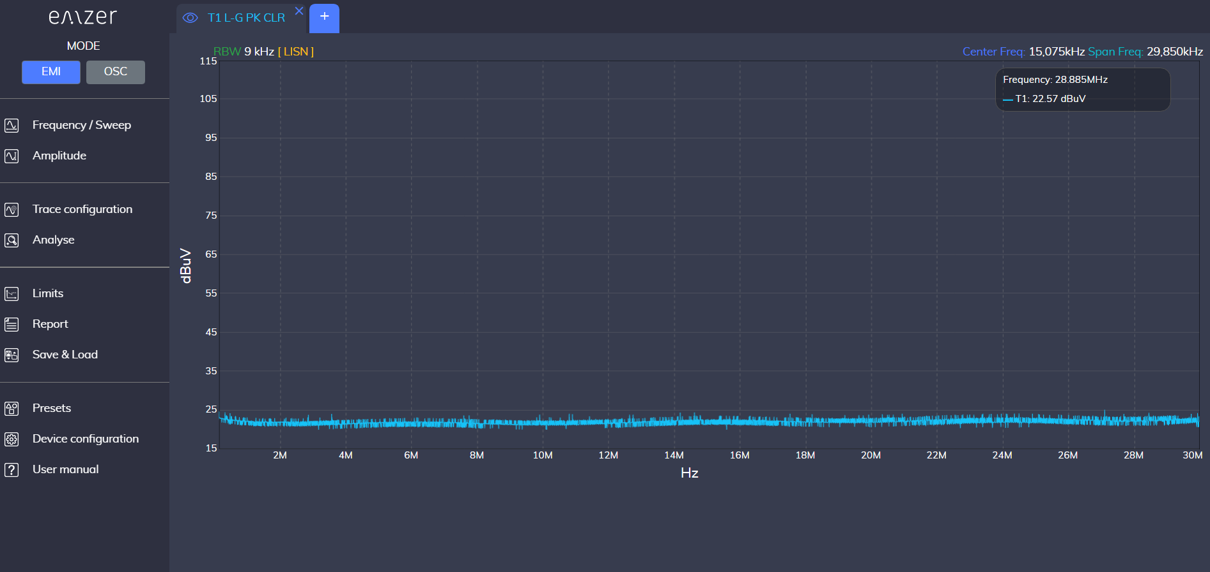
Figure 4. EMSCOPE main’s page.

3.12.2 Static Configuration
If the user wants to set the IP, it can be done in the configuration interface. To this end, click on the “Device Configuration” tab, and then “Network Configuration”. Alternatively, the same webpage is reachable by typing the following address in the URL field:
http://emscope-xxxx.local/ipconfig.php
where xxxx are the last 4 characters from the SN of your EMSCOPE. The SN is provided in the rear panel. The network configuration interface opens. By selecting the “Static IP configuration” option, an appearance similar to the interface shown in Figure 5 is obtained. The desired network configuration can be introduced following the described indications.
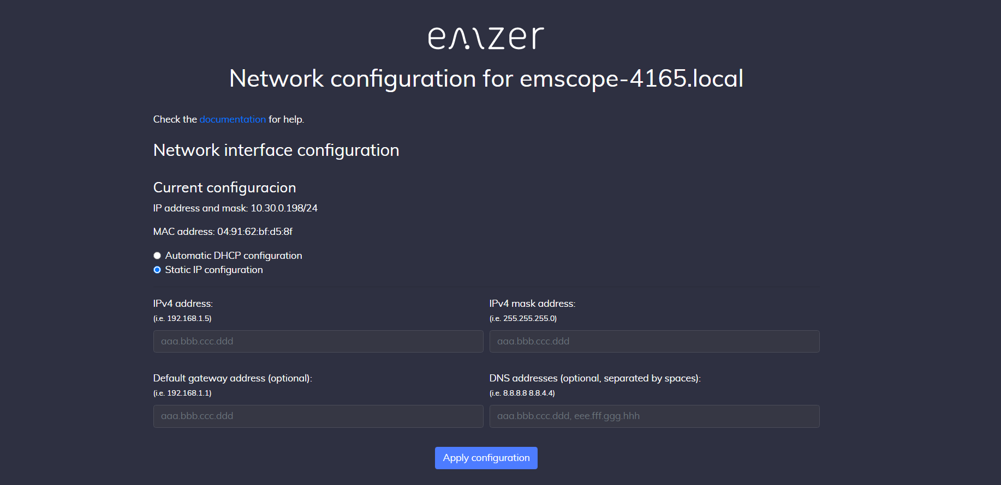
Figure 5. Network configuration interface.
Allowed static IP addresses are limited to class A and C.
Table 2-1 Private IP Addresses
Class | Private Network | Subnet Mask | Address Range
A | 10.0.0.0 | 255.0.0.0 | 10.0.0.1 - 10.255.255.254
C | 192.168.0.0 | 255.255.0.0 | 192.168.0.1 - 192.168.255.254

3.13 Using the Line Impedance Stabilization Network (LISN)
EMSCOPE must be bonded to the Protective Earth (PE) using the grounding bar placed in the rear panel. In case of using an external LISN, both need to be connected to the same PE.
Important! Before using the EMSCOPE's built-in LISN, follow the provided Safety information. Not following it can result in important damages, serious injuries and death.
To connect the EMI receivers to the built-in LISN for conducted interference measurements of an EUT, use the two N-connector bridges provided to connect the RF outputs of the LISN to the RF inputs of the receiver.
In order to avoid the unwanted tripping of the protection devices (due to the high leakage current inherently present in the LISN due to its construction made according to CISPR 16-1-2), an insulation transformer shall always be used between the mains supply and the LISN.

3.14 Transient Limiters
The built-in transient limiters are used to protect the input of the receiver from transient over voltages. Sometimes, the conducted disturbances entering the receiver through the LISN are too high - even if they cannot be seen on the EMSCOPE because they are out of the measurement bandwidth - and the associate energy is high enough to damage the input circuit. Two transient limiters (one for each line) are integrated in the system as a protection of the input from unexpected pulses and transients.
The maximum input level that the Transient Limiter support without equipment damage are 5 W (or, equivalently, 144 dBμV or 37 dBm, considering an input impedance of 50 Ω).

3.15 Quick start: connecting to EMSCOPE
To put EMSCOPE into operation and access it from a remote computer:
- Remove EMSCOPE from its cardboard shipping box.
- Connect a multimode fibre from the EMSCOPE SFP port to the SFP port of the media converter.
- Connect the media converter either:
  - To your LAN using a UTP Ethernet cable (Gigabit Ethernet media converter, e.g. TP-LINK MC220L), or
  - Directly to the remote computer using a fibre optic converter (e.g. StarTech US1GA30SFP).
- Connect the EMSCOPE rear-panel “LINE” mains socket using the supplied IEC 14 cable. Do not use the “EUT POWER INPUT” socket to power the EMSCOPE.
- Press the Power button. The green LED turns on to indicate that the instrument is powered. After a few seconds, the yellow LED turns on when the web server is ready.
- On the remote computer, open a web browser and type http://emscope-xxxx.local/ in the address bar, where xxxx are the last four characters of the EMSCOPE serial number on the rear panel.
- If EMSCOPE cannot be reached, try using its IP address directly or refer to Section 11 “Troubleshooting Guide”

4. EMI Receiver Operating Instructions
This section introduces the instrument interface, describes some important parameters that must be known for a suitable configuration of the instrument when configured in EMI receiver mode, and explains its main utilities.
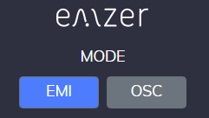
Figure 6. EMI mode.

4.1 Introduction
The EMSCOPE EMI Receiver is connected using a web browser as described above. The first time a user connects to the EMSCOPE (or when connecting using a clean session), a measurement with the default configuration is provided: one single trace measuring channel 1 (Line), RBW at 9kHz, Span 150 kHz – 30 MHz, Peak detector, Ref. Level at 100 dBμV, automatic attenuation, among other configurations.
The interface of the web app is shown in Figure 7. This interface has three important blocks. The red one contains the Main Menu, where the function keys are displayed. Each function key opens a submenu with the Action List (orange block), that is, all those settings that the user can configure for that function key. Each modification will be reflected in the Measurement Plot (blue block).
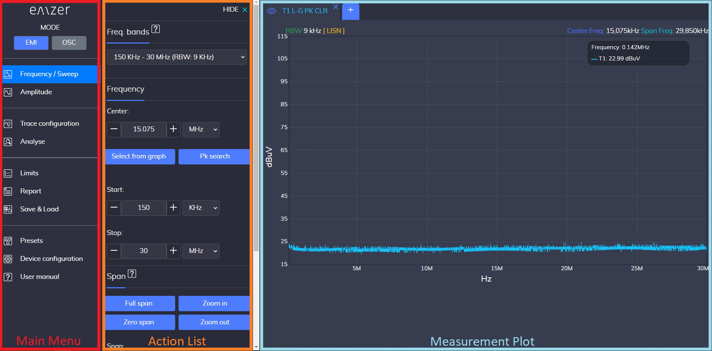
Figure 7. Web app interface.
The most relevant information regarding the measurement for each trace is provided one the trace tab, so the user can easily know what kind of measurement is currently configured. Information regarding the Center Frequency, Span and amplitude levels are reported on the top right corner.
If the user modifies the measurement configuration and closes the session, next time the user connects again to the EMSCOPE, the last configuration before closing is recovered.
Next Sections relate important considerations for the measurements and describe the relevant settings of the function keys.

4.2 Overload
For a correct measurement, be sure not to overload the EMSCOPE. Input attenuation must be properly configured considering the maximum amplitude expected at the input ports. Table 3-1 shows the maximum amplitude values that should be measured for each attenuator value to avoid distortion. If the signal surpasses this value, the EMSCOPE is saturated and will not present correct measurement values.
Important! Carefully consider that:
- Although EMSCOPE does not show any frequency bin with an amplitude value above the levels shown in Table 3-1, it may become saturated if the time-domain representation of the measured spectra is above them (saturation is produced in the ADC before processing the input signal). When this happens, a warning message is displayed in the measurement.
- Signals above 20 dBm will not be correctly measured in any case due to the activation of the transient limiters, clipping the input signal.
- Signals above 37 dBm (5 W) are not supported by the transient limiters and will damage the receivers.
- In case that an OVERLOAD indication occurs when using maximum attenuation, it is necessary to add an external attenuator to carry on the measurement without overpassing the declared limit. The user can use the “External Loss Attenuation” option to compensate the additional losses.
Table 3-1 Maximum amplitude values
Attenuator value (dB) | Maximum Amplitude (dBm) | Maximum Amplitude (dBμV)
0 | -28 | 79
1 | -27 | 80
2 | -26 | 81
3 | -25 | 82
4 | -24 | 83
5 | -23 | 84
6 | -22 | 85
7 | -21 | 86
8 | -20 | 87
9 | -19 | 88
10 | -18 | 89
11 | -17 | 90
12 | -16 | 91
13 | -15 | 92
14 | -14 | 93
15 | -13 | 94
16 | -12 | 95
17 | -11 | 96
18 | -10 | 97
19 | -9 | 98
20 | -8 | 99
21 | -7 | 100
22 | -6 | 101
23 | -5 | 102
24 | -4 | 103
25 | -3 | 104
26 | -2 | 105
27 | -1 | 106
28 | 0 | 107
29 | 1 | 108
30 | 2 | 109
31 | 3 | 110
32 | 4 | 111
33 | 5 | 112
34 | 6 | 113
35 | 7 | 114
36 | 8 | 115
37 | 9 | 116
38 | 10 | 117
39 | 11 | 118
40 | 12 | 119
41 | 13 | 120
42 | 14 | 121
43 | 15 | 122
44 | 16 | 123
45 | 17 | 124
46 | 18 | 125
47 | 19 | 126
48 | 20 | 127
49 | 20 | 127
50 | 20 | 127
51 | 20 | 127
52 | 20 | 127
53 | 20 | 127
54 | 20 | 127
55 | 20 | 127
56 | 20 | 127
57 | 20 | 127
58 | 20 | 127
59 | 20 | 127
60 | 20 | 127
61 | 20 | 127
62 | 20 | 127
63 | 20 | 127
64 | 20 | 127
65 | 20 | 127
66 | 20 | 127
67 | 20 | 127
68 | 20 | 127
69 | 20 | 127
70 | 20 | 127
71 | 20 | 127
72 | 20 | 127
73 | 20 | 127
74 | 20 | 127
75 | 20 | 127
76 | 20 | 127
77 | 20 | 127
78 | 20 | 127

4.3 Reference Level
The Reference Level sets the top magnitude value of the Measurement Plot. It can be configured in the tab Amplitude from the Main Menu. If the Input Attenuator is configured in the Automatic mode, the Reference Level automatically fixes the Attenuator value according to Table 3-1. By moving the measured signal close to the Reference Level (without overpassing it and always avoiding an overload), the best possible exploitation of the ADC's dynamic range is accomplished, obtaining more accurate measurements.
If the Input Attenuator is not set to Automatic mode, the Reference Level setting is decoupled from the input gain, which means that the gain (or attenuation) remains constant; in such cases, changing the Reference Level only influences the representation of the signal on the display through numeric scaling.

4.4 Dwell Time
The dwell time can be found in the tab Sweep from the Main Menu. This value, expressed in seconds, defines the time that the detectors are measuring the input signal. Since all frequencies are measured simultaneously, the measurement time is equal to the dwell time. Therefore, a dwell time of 2 seconds means that the measurements are performed for 2 seconds. In addition, because the equipment is continuously measuring, the magnitudes are refreshed every 2 seconds.

4.5 Traces and Detectors
EMSCOPE has been designed to allow the use up to six simultaneous detectors: two Peak, two Quasi-Peak and two Average detectors (one of each for each input line). Quasi-Peak and Average Detectors have been implemented to meet CISPR 16-1-1 Standard. All six detectors run in real time. The detectors can be selected in the tab “Trace configuration” from the Main Menu.
Each detector has its own trace. A new trace (or tab) can be opened clicking on the  symbol (located just after the name of the last opened trace). Up to six traces can be opened simultaneously. Although all active traces are displayed simultaneously, they can also be hidden by clicking on the eye symbol (located just before the name of the trace): .

4.5.1 Peak Detector
This detector gives the maximum level observed in each measured spectral line during the configured measurement time (dwell time).
This detector is calibrated to give the rms value of an unmodulated sinusoidal signal.
For unmodulated signals, dwell time can be configured as low as possible. For modulated o pulsed signals, the dwell time must be configured to record at least one period or pulse of the signal.

4.5.2 Quasi-Peak Detector
This detector gives the maximum level observed at each weighted spectral line. The spectral lines have been weighted according to CISPR 16-1-1. Depending on the selected frequency band, the detector is automatically configured to meet CISPR 16-1-1 specifications. It is calibrated to give the rms value of an unmodulated sinusoidal signal.
This detector involves long measurement times (dwell time). For CISPR 16 band A (9-150kHz) at least a dwell time of 2 seconds must be configured. For CISPR 16 band B (150kHz-30MHz), at least a dwell time of 1 second must be configured. This guarantees a correct weighting of pulsed signals with repetition frequency as low as indicated in the specifications. For unmodulated signals or faster repetition frequencies, lower dwell time can be configured.

4.5.3 CISPR Average Detector
This detector gives the weighted average level of each measured spectral line. The spectral lines have been weighted averaged according to CISPR 16-1-1. The average detector is useful to measure narrowband signals to overcome problems associated with either modulation content or the presence of broadband noise. The CISPR average detector is calibrated to give the rms value of an unmodulated sinusoidal signal.
In order to perform the correct weighting of the signal, the dwell time have to be configured long enough. For unknown signals, at least a dwell time of 1 second must be configured. This guarantees a correct weighting of pulsed signals with repetition frequency as low as indicated in the specifications.

4.6 RBW Filters
The Resolution Bandwidth is used to select the bandwidth of the measuring filter. It is found in the tab Trace from the Main Menu. The drop-down menu allows the user to select between the CISPR bandwidths 200 Hz, 9 kHz and 120 kHz, or the MIL bandwidths 1 kHz and 10 kHz. These filters are mathematically modelled using digital techniques to be compliant to the two standards (CISPR 16-1-1 and MIL-STD-461E) Band A, B and C.

4.6.1 Single-Band Measurements
When selecting the 200-Hz or 1-kHz bandwidth filter, measurements are provided up to 150 kHz (Band A). When selecting the 9-kHz or 10-kHz bandwidth filter, measurements are provided up to 30 MHz (Band B). When selecting the 120-kHz bandwidth filter, measurements are provided up to 110 MHz (Band C).

4.6.2 Dual-Band Measurements
It is possible to show measurements using two different RBW filters simultaneously. The two possibilities are:
- CISPR bandwidths 200 Hz and 9 kHz.
- MIL bandwidths 1 kHz and 10 kHz.
When selecting this option, measurements from 9 kHz up to 150 kHz (band A) are done with the smaller filter (either 200 Hz or 1 kHz), and from 150 kHz to 30 MHz (band B) are done with the highest filter (9 kHz and 10 kHz).

4.7 EMI and Modal Measurements (Channel)

4.7.1 Single phase measurements
EMSCOPE can measure line and neutral simultaneously using the three detectors for each one (that is, six detectors running simultaneously in six different traces). This is called here EMI measurements. Alternatively, modal measurements (that is, common-mode and differential-mode emissions) can also be done instead of line and neutral, using the same six detectors.
The selection between EMI and modal measurements can be done in the tab Trace Configuration from the Main Menu. L-G and N-G are the line and neutral measurements respectively (that is, and ). CM and DM are the common mode and differential mode respectively (that is, and ). It should be noted that line and neutral measurements are only done when the “EMI measurement” button is selected. Otherwise, these measurements remain in a paused mode. In the same way, common-mode and differential-mode measurements are only done when the “Modal measurements” button is selected. Otherwise, these measurements remain in a paused mode. The reason for that is that the same six detectors (two peak, two quasi-peak and two average) are shared between the EMI and modal emissions, so that when one of them is selected, the other cannot be measured.
Modal measurements are computed as shown below:
,
.

4.7.2 Three phase measurements
EMSCOPE RX4 can measure up to two lines simultaneously (any pair of , , or ) using the three detectors for each one (that is, six detectors running simultaneously in six different traces). This is called here EMI measurements. When measuring one or two lines, measurements are continuous and there are no gaps (there is not loss of information). When measuring three or four lines, EMSCOPE switches automatically between them every dwell time. That means that while one of the pair of lines is being measured, the other line/s are ignored (there is loss of data), and vice versa.
Alternatively, modal measurements (that is, common-mode and differential-mode emissions) can also be done instead of EMI measurements, using the same six detectors. The selection between EMI and modal measurements can be done in the tab Trace Configuration from the Main Menu. L1, L2, L3 and N are the EMI measurements (that is, , , and ). CM, DM1, DM2 and DM3 are the modal measurements (that is, , , and ). It should be noted that EMI measurements are only done when the “EMI measurement” button is selected. Otherwise, these measurements remain in a paused mode. In the same way, modal measurements are only done when the “Modal measurements” button is selected. Otherwise, these measurements remain in a paused mode. The reason for that is that the same six detectors (two peak, two quasi-peak and two average) are shared between the EMI and modal emissions, so that when one of them is selected, the other cannot be measured. In the same way, when measuring one or two modes, measurements are continuous and there are no gaps (there is not loss of information). When measuring three or four modes, EMSCOPE switches automatically between them every dwell time. That means that while one of the pair of modes is being measured, the other mode/s are ignored (there is loss of data), and vice versa.
Modal measurements are computed as shown below:
- If Neutral line is not used:
,
.
.
.
- If Neutral line is used:
,
.
.
.

4.7.3 Advanced modal configuration
A new feature that allows the user to define the modal decomposition explicitly by providing custom mode definitions as linear combinations of the measured line voltages has been added. All coefficients are complex-valued, allowing both magnitude and phase weighting (i.e., real and imaginary parts).

4.7.3.1 Single-phase network
For a single-phase system with line () and neutral (), the modes are defined as:
.
.

4.7.3.2 Three-phase network without neutral
For a three-phase system with line voltages VL1, VL2, and VL3:
.
.
.
.

4.7.3.3 Three-phase network with neutral
If the neutral conductor is present, VN is included in the definitions:
.
.
.
.
This flexible formulation allows the user to implement standard modal decompositions or custom mode definitions, enabling advanced analysis of conducted emissions under a wide range of measurement configurations.

4.8 External Loss Attenuation
Losses added by external components of the measurement setup can be introduced to be considered in the measurement. External losses can be introduced and activated in the tab “Amplitude”. The user can create a table defining the external losses at different frequencies (at least two frequency points are needed). The software interpolates the table when doing the measurements so that each frequency bin is compensated suitably. To consider the external losses in the measurement plot, the option “Activate external loss attenuation” must be selected.
Additionally, the created external losses can be saved to a file and retrieved later by loading them. The file format used is JSON and it can be easily edited using any plain text editor.

4.9 Current probe transfer impedance factor
Current probe transfer impedance factors can be defined and applied to measurement results. Transfer impedance data can be entered and enabled in the Amplitude tab.
The user defines the transfer impedance by creating a table with values at different frequencies (a minimum of two frequency points is required). During the measurement, the software interpolates these values so that the appropriate transfer impedance is applied to each frequency bin.
To apply the transfer impedance compensation to the measurement plot, enable the Activate transfer impedance option. Once enabled, the measurement units change to dBμA.

4.10 Pulse Repetition Frequency
If the equipment displays the warning message “PRF < 20 Hz”, it indicates that the EUT is emitting pulses with repetition frequencies below 20 Hz.
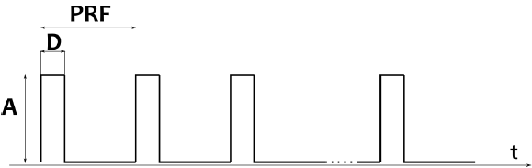
CISPR 16-1-1:2019 states in section 5.2 that the equipment where the requirements for pulse repetition frequences less than 20 Hz are not meet, can be used for compliance testing provided the suitablity of the equipment has been evaluated according to the Annex B of the CISPR 16-2-1:2014, Annex B of the CISPR 16-2-2:2010 or the Annex E of the CISPR 16-2-3:2016:
- CISPR 16-2-1 and CISPR 16-2-2 on their annexes B inform about the general characteristics that the spetrum analyzers and scanning receivers should have been taken into account. That is, considerations about overload, linearity, selectivity, normal response to pulses, peak detection, frequency scan rate, signal interception, average detection, sensitivity and amplitude accuracy.
- CISPR 16-2-3:2016 on its annex E indicates how to determinate the suitability of spectrum analyzers for compliance tests with pulse repetition frequencies below 20 Hz. Specifically the annex descrives a simple method to verify the validity of the measurements for the quasi-peak detector. This method is based on the comparison between the reading obtained with the peak and quasi peak detector. If the difference between them is above the indicated in Table 4-1, and the amplitude of the signal is close to the applicable limit, a measuring receiver that complies with the CISPR 16-1-1 specifcations for low pulse repetition frequencies is to be used.
Table 4-1 Maximum allowed amplitude difference between peak and quasi-peak detected signals. CISPR 16-2-3. Annex E. (Note: Values for PRF = 20 Hz).
Band A | Band B
7 dB | 13 dB
All the applicable requirements present in the annexes are met by the EMSCOPE receivers:
- The equipment fulfills the applicable paragraphs of annex B of CISPR 16-2-1 and CISPR 16-2-2 as stated in its specifications and calibration reports. In addition, the equipment checks if its input stages are saturated avoiding incorrect results due to overload.
- The equipment accomplishes with annex E of CISPR 16-2-3 because the difference between the peak and the quasi-peak detector can be examined. Moreover, provided that the equipment fulfills CISPR 16-1-1 specifications for PRFs < 20 Hz, the maximum amplitude difference between the peak and the quasi-peak detected signals can be increased to the values indicated in the next table:
Table 4-2 Maximum allowed amplitude difference between peak and quasi-peak detected signals taking into account the EMSCOPE response.
 | Difference | Comments
Band A | 13.5 dB | with a PRF = 5 Hz
Band B | 16.5 dB | with a PRF = 10 Hz
It is important to note that even if the actual level of these broadband interferences is below the noise level, there is no risk of misconfiguring the equipment and allowing these high amplitude interfering signals saturate the input stages, since the equipment always warns if this occurs.
The EMSCOPE is compliant with the CISPR 16-1-1 as it fullfills the requirements included in the forementioned CISPR 16-1-1 and in the related annexes of the CISPR 16-2-1, CISPR 16-2-2 and CISPR 16-2-3. Therefore, the correctness of the measurements is garanteed and the equipment can be used as a CISPR 16-1-1 receiver.

4.11 Utilities

4.11.1 Options overview
EMSCOPE interface has been designed to provide an optimal user experience and usability. To this end, all options have been grouped so that any measurement can be configured with the minimum number of clicks.
- Frequency/Sweep and Amplitude tabs group all options that affect all measurements (or traces) that are displayed simultaneously. By modifying either the frequency band, the start, center and stop frequency, the sweep and dwell time, the reference level, the input attenuator, the units or the external loss attenuation, all measurements will be updated accordingly.
- Trace configuration, on the other hand, groups all options that affect only the active trace. In this tab, the user can configure the trace type, the channel and the detector. Each trace can be configured independently of the other traces. The only exception is the EMI or Modal measurements selection.
- Analyse contains all those options that allow to obtain a deeper analysis of the measurement plot: Markers, Multi-markers, peak search and delta marker.
- Limits and Report allows plotting standardized (or, if desired, customized) emission limits to compare the measurements, and generating reports in pdf format.
- Save & Load allows exporting and importing measurements in different formats.
- Presets allows reloading measurement configurations.
- Device configuration provides information of the EMSCOPE such as MAC address, IP address, serial number, software version and temperatures. It allows modifying the interface colors, the network configuration or updating the device.

4.11.2 Zooming into the diagram
The user can zoom into the diagram to visualize the measurement results in greater detail.
This can be done in several ways:
- Using the soft keys “Zoom in” and “Zoom out”, that can be found in the Action List from the tab “Frequency”.
- Modifying the span value, in the Action List from the tab “Frequency”.
- Modifying the “Center”, “Start” and “Stop” values, in the Action List from the tab “Frequency”.
- Clicking directly in the Measurement plot with the left button of the mouse and, without releasing it, dragging the pointer horizontally (for a zoom into a frequency band) or vertically (for a zoom into an amplitude zone). Full span can be recovered by clicking twice on the Measurement plot.

4.11.3 Markers
Markers are available in the tab “Analyse”. To add a marker in the Measurement Plot, the user has either to write the frequency in the form of the Action List or select it by clicking on the desired position of the Measurement Plot or use the “Pk search” option that will look for the highest peak of the active measurement. Finally, click on the “New Marker” button to add the marker.

Normal markers and Multi-trace markers
There are two types of markers: normal markers and multi-trace markers. Normal markers are placed only on the active trace. Multi-trace markers are placed on all traces simultaneously.
Delta marker (Action List) allows to compare the distance in frequency and amplitude between two markers. Besides, a Delta Table is automatically shown below the measurement plot to show all amplitude marker deltas.

4.11.4 Limits
Users can add and delete their own standard limits to compare the measurements with them. Since limits are usually stablished in a logarithmic sweep, when any standard is plotted, the measurement plots jump (if not already) to logarithmic scale.

4.11.5 Report
The Report tab allows obtaining an automatic list with the maximum peak levels of a measurement. In this tab there are a few options to customize the automatic search and to configure the output document report.
Under the Setup description field, the user can introduce some text to identify the measured EUT, the operator, and the measurement setup. This information will appear in the pdf of the report.
In the Automatic SW parameters section, the user can configure the peak-search algorithm by means of two parameters:
- The Number of Subranges is used to divide the spectra in equidistant ranges. In each of this ranges, the algorithm only shows a single peak. The more the subranges introduced, the more peaks that are shown.
- The Margin (dB) value is a parameter that is only considered when there is a limit plotted along with the measurement. In that case, EMSCOPE automatically provides a list of all the emission peaks that are above the limit or close below by the margin value. If all emissions fall below this margin, the user will receive an empty list. In order to include emissions far below the limit, the margin must be increased so that it covers the distance between the emissions and the limit. For instance, if there is a peak 20 dB below the limit and it is desired to have it automatically in the output list, the margin should be 20 dB at least. If there is no limit, the Margin (dB) value is skipped.
There are two modes to obtain the list of maximum emissions and generate a report:
- Tabs: This mode searches for peaks in the active traces using the user's configuration (trace type, channel, detector and frequency span). If the user has opened, for instance, three traces, the software will search for peaks in each of these three traces. For each trace, if there is a limit plotted, the software searches for peaks above the value limit - margin and shows, if there is any, a peak per subrange. If there is no limit for a trace, the software shows the maximum value in each subrange (without considering the margin value).
- Standard: This mode uses the frequency range and the detectors defined in the active limit for both line and neutral terminals. In this mode, the list only shows peaks for those detectors that have a limit. Otherwise, they do not appear in the list, independently of the opened traces.
In both cases, the user can select to add additional peaks of their own by selecting the option Append user markers in the dropdown menu above. The automatic search can also be disabled if the option Only markers is selected (only the markers added by the user are considered to generate the list and the report).
Finally, the button List of maximum emissions plots a list with the highest emission levels of the measurement, obtained according to the configuration described above. And the button Generate Report opens a new browser window where a preliminary report is displayed. The user can add additional information about the measurement, upload an image and remove peak emissions from the report if they are not desired. Once the user has finished, the report can be downloaded in a pdf format.

4.11.6 Save & Load options
There are different options to save the measurements. They are described below:
- Save measures in CSV: this option downloads a comma-separated values (CSV) file containing the values of the measurements. The downloaded file can be opened in spreadsheet editors like Microsoft Excel, LibreOffice or Google Docs, among others.
- Save offline version: this option downloads a ZIP file that contains a usable offline version of the system. The downloaded file can be decompressed in any other computher, with or without connection to the EMSCOPE, and opened. The HTML file will show the same traces and measurements as those present when the ZIP file was generated, allowing further data analysis. The interface will still allow limited functionality, such as using markers or zooming the plot. It can be usefull to share information about the measurement.
- Save graph image: this option downloads the current plot of the measurement in a JPEG format.
- Save spectrogram image: this option downloads the spectrogram measurement in a JPEG format (only available when the spectrogram is activated).
- Save session file: this option downloads a JSON file that contains all the current session information (detectors, traces, RBW, markers, reference level, sweep time, etc.). The difference with the “Save session settings” option (see Presets Section) is that in this case, the information is downloaded to the computer instead of storing it in the EMSCOPE instrument.
Additionally, the user can also upload measurements and sessions:
- Load session from file: this option allows the user to upload a previously downloaded session to recover the stored configuration.
- Load measures from CSV file: this option allows the user to upload a previously downloaded measurement in CSV format for comparison purposes.

4.11.7 Presets
- Start with default settings: this option removes all current configurations and starts a new connection to the instrument with the default settings: a single tab, band B, reference level to 115 dBμV, EMI measurements on line terminal, clear/write and without markers nor limits.
- Save session settings: this option stores all current session information (detectors, traces, RBW, markers, reference level, sweep time, etc.). The difference with the “Save session file” option (see Save & Load options Section) is that in this case, the information is stored in the EMSCOPE instrument instead of downloading it to the computer.

4.11.8 Health Status and Self test
The instrument EMSCOPE has some tools that show the health status of the instrument. In Device Configuration → Health status, the instrument shows if there has been some kind of error in its internal communications (Figure 8). When the instrument is working properly, the four comms should show “0 errors”. Sporadic and low count errors could occur, but that is part of normal operation of the device, since they are detected and corrected. If the error count is high, that could effectively indicate a malfunctioning hardware issue. Please read below.
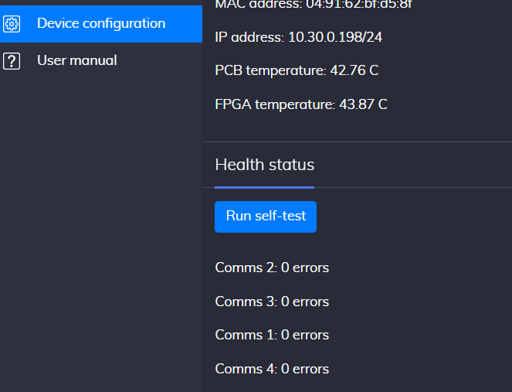
Figure 8. Health status section.
Additionally, the user can perform a self test clicking on the button “Run self test”. In that case, a new web page is opened where all peripherals are tested to check their performance. If the instrument is working properly, all tests should be passed. Note that you will not be able to use the device during this short period of time.
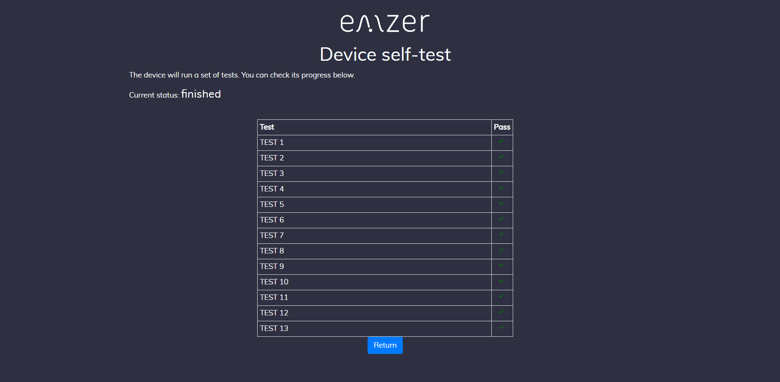
Figure 9. Self test.

4.11.9 Licenses
The different funcionalities of the EMSCOPE instrument are activated via a License system. Please, contact your distributor if you are interested in a new functionality for your instrument not active yet.
To activate a new License, click on “Device configuration” in the main menu and then click on “Licenses”.
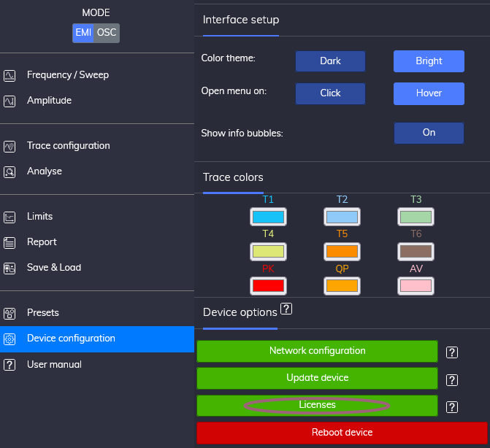
Figure 10. Licenses button in Device Configuration.
The activated licenses of the EMSCOPE appear now in the low part of the web, as seen below.
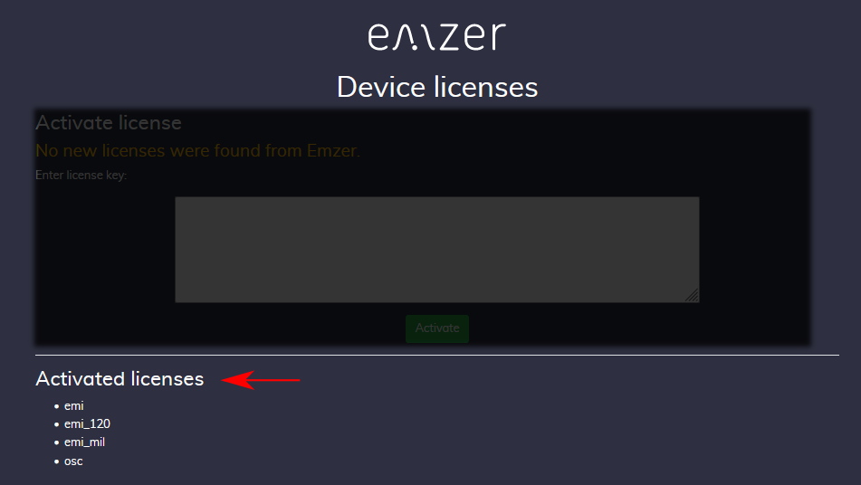
Figure 11. Activated Licenses.
If the computer has access to https://emzer.com/, the user is notified if new licenses are available for that specific EMSCOPE and will be prompted to activate them.
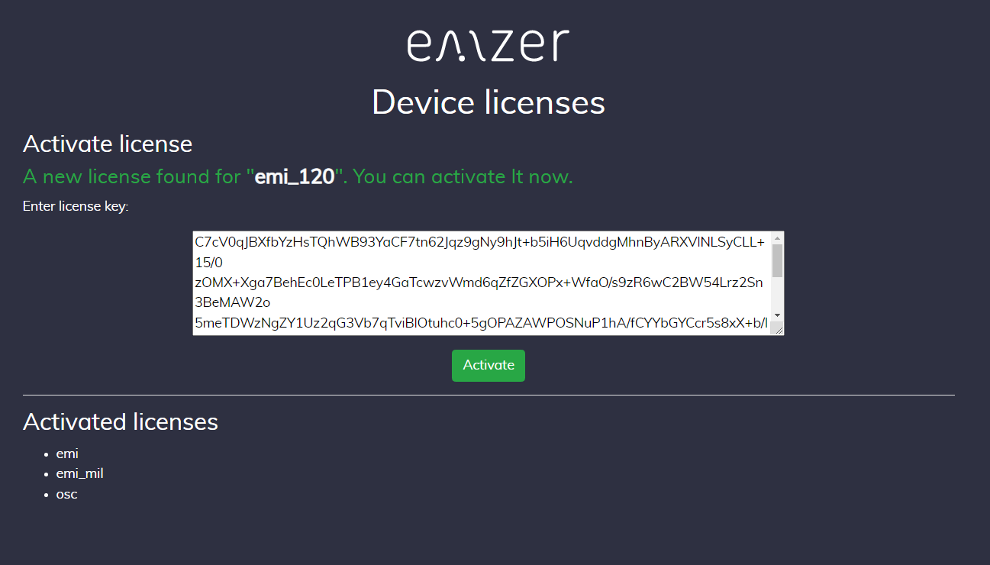
Figure 12. Output text when new licenses are found.
If the computer does not have access to https://emzer.com/, or there are not new licenses available, the message states that no new licenses were found:
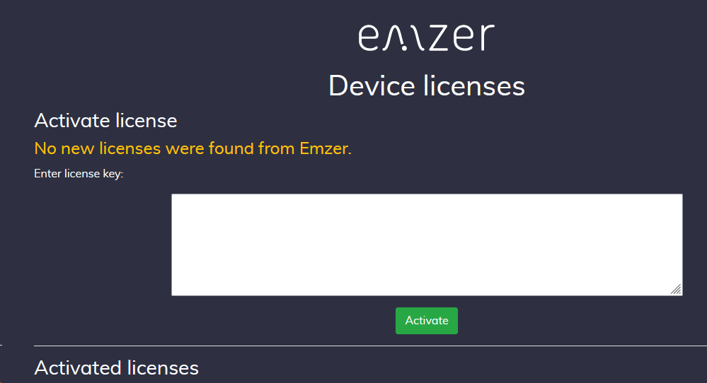
Figure 13. Output text when no new licenses are found.
A license can be activated offline by manually introducing the license code in the text box.
In both cases (automatic or manual), after clicking on the “Activate” button, the new license is installed.
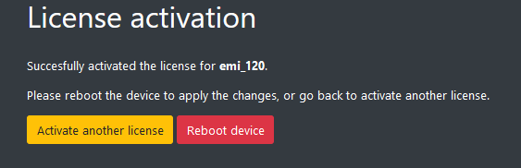
Figure 14. License activation.
Once the user has introduced all new licenses, the EMSCOPE needs to be rebooted. After rebooting the device, the new licenses become active.

5. Oscilloscope Operating Instructions
This section introduces the oscilloscope mode and explains its main utilities. The OSC mode is activated when clicking on the OSC button
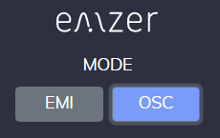
Figure 15. OSC button.

5.1 Introduction
The EMSCOPE OSC mode is connected using a web browser as described above. The first time a user connects to the EMSCOPE (or when connecting using the “start with default settings” option), a measurement with the default configuration is provided: one single trace measuring channel 1 (Line), Scale 1V/div (vertical) and 1μ/division (horizontal), among other configurations. The interface of the web app is shown in Figure 16.
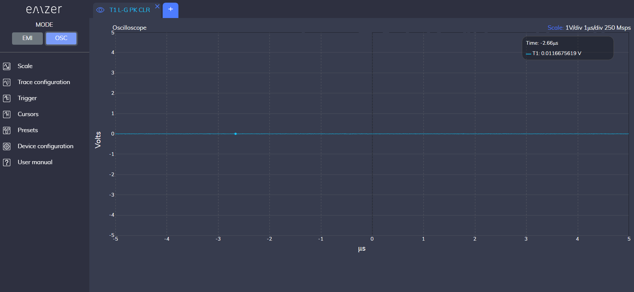
Figure 16. Web app interface.
The most relevant information regarding the measurement for each trace is provided in the trace tab. Information regarding the scale and sampling frequency are reported on the top right corner.
If the user modifies the measurement configuration and closes the session, the next time the user connects again to the EMSCOPE, the last configuration before closing is recovered.
Next Sections relate important considerations for the measurements and describe the relevant settings of the function keys.

5.2 Scale
The Scale menu allows to configure the instrument for a suitable measurement. The user can select the amplitude and time division factors.
The relationship between the time-division factor and the sampling frequency is shown in Table 5-1:
Important! The time division factor directly affects the sampling frequency of the measurement, as shown on the top right corner. For sampling frequencies below 250 Msps, aliasing can appear.
Table 5-1 Relationship between time-division factor and sampling frequency
Time/division | Sampling Frequency
200 ms | 3.125 ksps
100 ms | 6.25 ksps
50 ms | 12.5 ksps
20 ms | 31.25 ksps
10 ms | 62.5 ksps
5 ms | 125 ksps
2 ms | 312.5 ksps
1 ms | 625 ksps
500 μs | 1.25 Msps
200 μs | 3.125 Msps
100 μs | 6.25 Msps
50 μs | 12.5 Msps
20 μs | 31.25 Msps
10 μs | 62.5 Msps
5 μs | 125 Msps
2 μs | 250 Msps
1 μs | 250 Msps

5.3 Trigger
The trigger decides when the acquisition system begins acquiring, and can be used to stabilize the displayed waveform or to know if the signal reaches a certain voltage level. The trigger can be activated going to the Trigger menu and clicking on the trigger button. The red cursors indicate the required level that the voltage of the waveform need to reach in order to start the capture (Figure 17). This level can be modified dragging the cursors with the mouse or introducing the desired level in the Action List column.
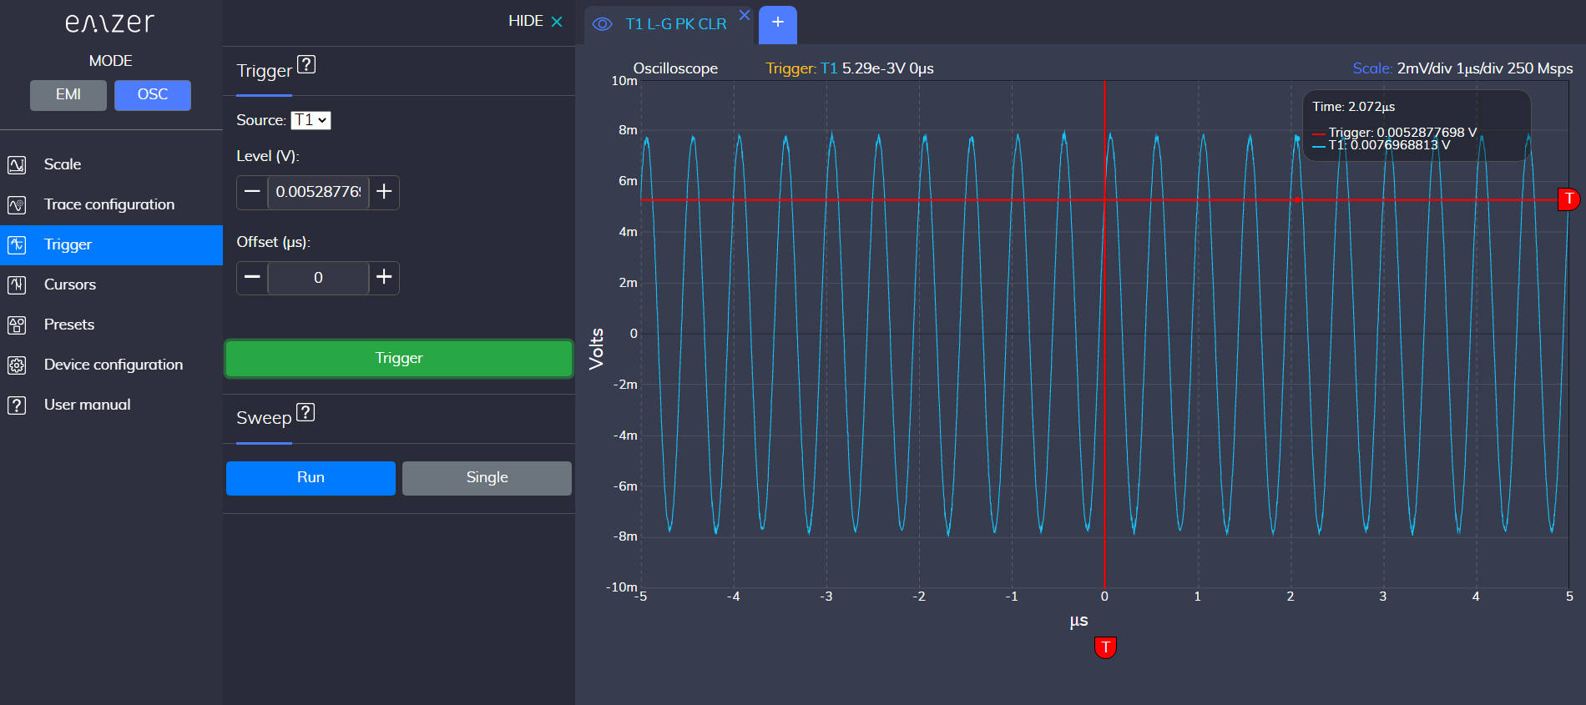
Figure 17. Data capture using the trigger option.

5.4 Cursors
Cursors allow the user to manually identify points on a scope trace. There are two cursors for each dimension, which allows readout of the vertical or horizontal difference value. Again, the amplitude at each cursor position relative to the channel’s offset appears along with the difference of the values, marked as ΔCursors, and the equivalent time difference in the horizontal readout field, designated ΔCursors.
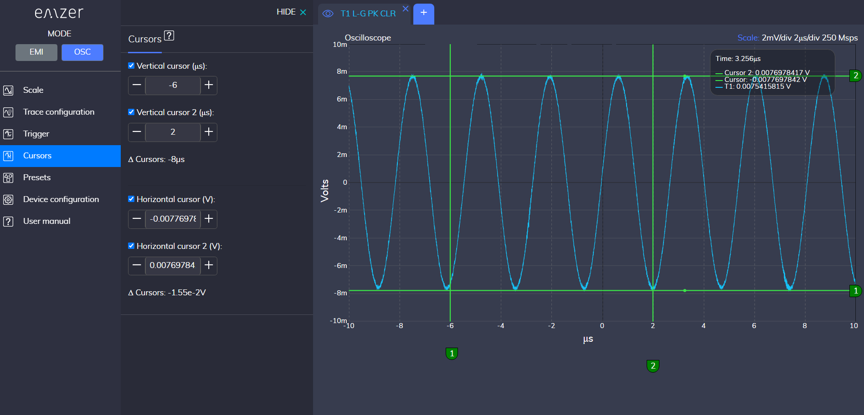
Figure 18. Cursors option.

6. Clickmeter Operating Instructions
This section introduces the clickmeter mode and explains its main utilities. The clickmeter mode is activated when clicking on the CLICK button.
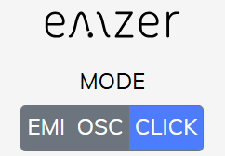
Figure 19. Clickmeter button.

6.1 Introduction
The EMSCOPE Clickmeter mode is accessed via a web browser, as previously described. Upon the first connection—or when using the “Start with default settings” option—the system automatically launches a measurement using the default configuration. This includes a single trace measuring the four Line channels, a Result Table below, and the configuration menu, as illustrated in Figures 20 and 21.
The four Line channels correspond to the following frequencies: 150 kHz (Channel 1), 500 kHz (Channel 2), 1.4 MHz (Channel 3), and 30 MHz (Channel 4).
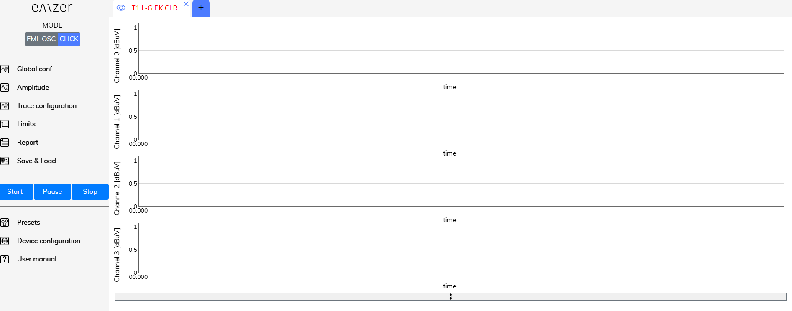
Figure 20. Web app interface.
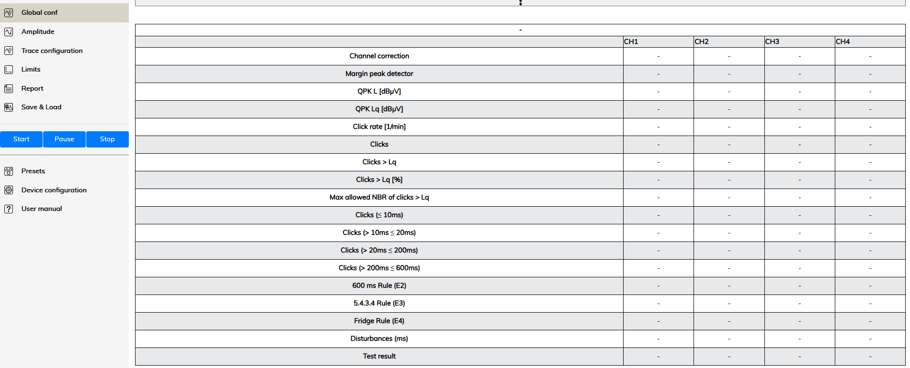
Figure 21. Table results.
The most relevant information regarding the measurement for each trace is provided in the trace tab.
If the user modifies the measurement configuration and closes the session, the next time the user connects again to the EMSCOPE, the last configuration before closing is recovered.
Next Sections relate important considerations for the measurements and describe the relevant settings of the function keys.

6.2 Global Configuration
Figure 22 shows the menu that appears when clicking on the Global Conf option.
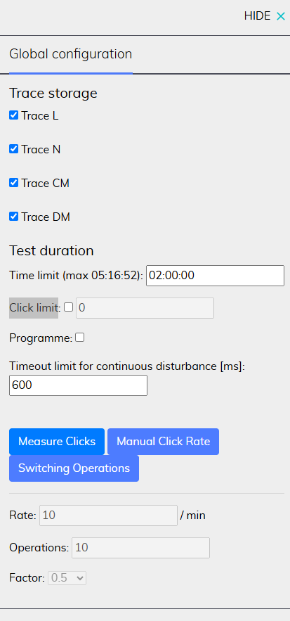
Figure 22. Global configuration menu.

6.2.1 Trace Storage and Test Duration
Trace storage allows users to select which traces to store: Line (L), Neutral (N), Common Mode (CM), and/or Differential Mode (DM), as shown in Figure 23.
The number of selected traces directly affects the maximum storable duration, which is displayed next to the Time limit field (in parentheses). The user can specify the desired test duration in this field (hours:minutes:seconds), which must always be less than or equal to the indicated maximum.
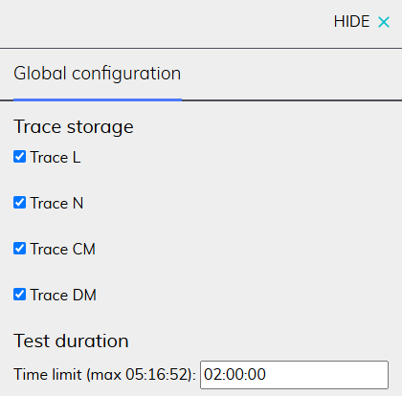
Figure 23. Trace Storage and Test Duration.

6.2.2 Click limit

Figure 24. Click limit box.
If selected (as shown in Figure 24), the test stops when the number of measured clicks reaches the value specified by the user. If not selected, a default click limit of 40 clicks is applied.

6.2.3 Mode Programme
If the Equipment Under Test (EUT) operates according to a defined programme, this mode must be selected. In this mode, the following conditions must be preserved:
- If the click rate observed during a complete programme is less than or equal to 0.5 clicks per minute, and the programme duration exceeds 20 minutes, the minimum observation time is equal to the duration of a complete programme.
- Otherwise, the minimum observation time is either:
  - The total duration of the minimum number of complete programmes required to detect 40 clicks at one of the two reference frequencies, or
  - The total duration of the minimum number of complete programmes that exceeds 120 minutes, if after 120 minutes fewer than 40 clicks have been recorded.

6.2.4 Measure Clicks/Manual Click Rate/Switching Operations
Three operating modes are available:
- Measure Clicks (default mode): The test continues until 40 clicks are detected or until the user-defined measurement time is reached.
- Manual Click Rate: Allows the user to manually set the click rate (Nc, clicks per minute).
- Switching Operations: In this mode, a new click rate (Ns) is computed based on the type of EUT, according to Annex B (Table B.1) of CISPR 14-1.

6.3 Trace Configuration
The “Trace Configuration” menu can be seen in Figure 25.
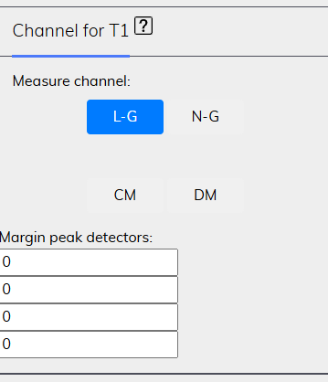
Figure 25. Trace Configuration.

6.3.1 Measure Channel
This menu allows to select the suitable trace for the selected tab.

6.3.2 Margin Peak Detectors
There are four text boxes, each corresponding to one of the trace channels (Channel 0, 1, 2, and 3). The margin value is used to shift the standard limit line upward in thoses cases where the measured noise exceeds the specified limit.

6.4 Limits
As in the EMI configuration, the Limits menu allows the user to select the standard limit applicable to the clickmeter measurement. In this mode, however, only limits corresponding to Band B are available for selection.
Important! A standard limit must be selected and the “Activate Standard” option must be enabled before a test can be initiated.
Figure 26. Limits.

6.5 Report
The Generate Report button creates an automatic test report in a new web browser window. If desired, the report can be downloaded as a PDF by clicking the Download button (as shown in Figure 27). Figure 28 shows an example of a result table shown in the report's window.
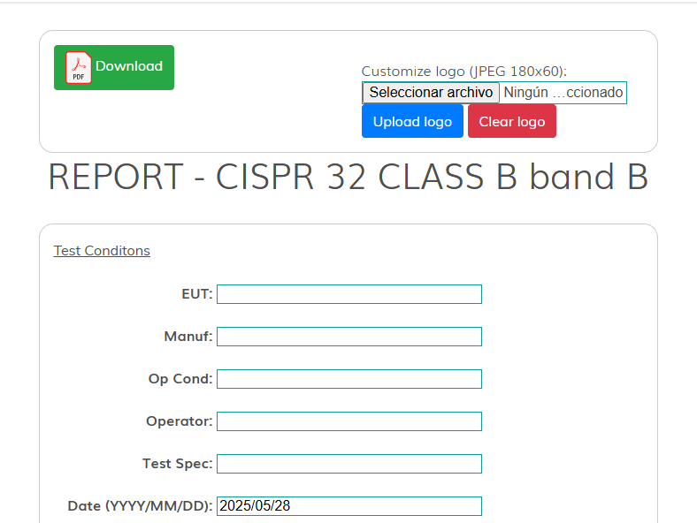
Figure 27. Report (download button).
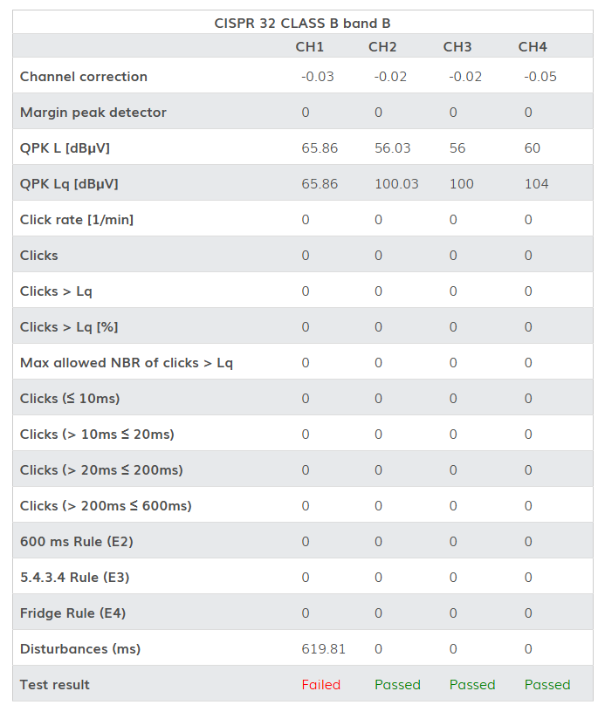
Figure 28. Report's table.

6.6 Start/Pause/Stop
These options are shown in Figure 29.
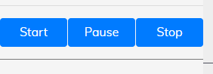
Figure 29. Start, Pause and Stop options.
- Start: Initiates the clickmeter test.
- Pause: Temporarily pauses the clickmeter test. The test can later be resumed by clicking the Start button or terminated by clicking the Stop button.
- Stop: Terminates the clickmeter test.

7. Applications

7.1 Conducted Emissions
All electric and electronic devices are potential generators of EMI. The term EMI thus refers to the unintended electromagnetic energy emitted by a device which propagates itself along cables or through the air and couples with other devices that are present in the surroundings. These electromagnetic fields (conducted or radiated interference) may generate interfering currents and voltages into nearby equipment and therefore can cause possible malfunctions. In order to prevent and control such interference there are a number of national and international standards, like IEC, which specifies limits and methods of tests. Moreover, within the European Union the application of several European Norms on Electromagnetic Compatibility is enforced by law and therefore the commercialization and use of all the electric and electronic equipment is subject to the measurement of the EMC characteristics, which must be within well-defined limits.
The conducted emissions are the noise currents and voltages that propagate through the power cord or harness to other components/systems or power grid. The EMI currents (or voltages) of the two conductors relative to each other and with reference to the ground form a vector system where two kinds of currents (or voltages) are present. They are:
- The differential-mode noise (DM), defined as the noise that appears across power supply lines and is in series with the power supply line, and the noise current flows in the same direction as the power supply current (Figure 19.a).
- The common-mode noise (CM), defined as the noise current that has leaked via a stray capacitance through ground and returns to the power supply line (Figure 19.b).
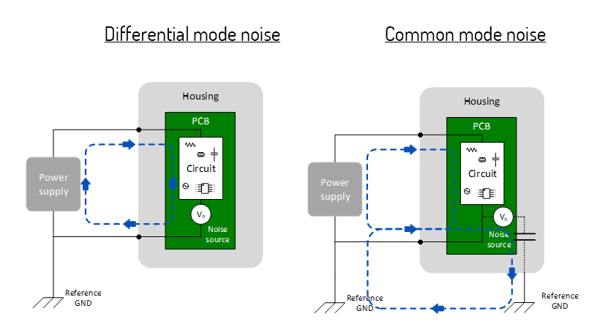
Figure 19. Modal definition of interference: (a) DM. (b) CM.
To reduce the conducted emissions a power-line filter needs to be placed between the power-line terminals and the Equipment Under Test (EUT). In its simplest structure, it contains a X capacitor between line and neutral to mitigate the DM and a CMC and two Y capacitors from line to ground and neutral to ground to mitigate the CM.
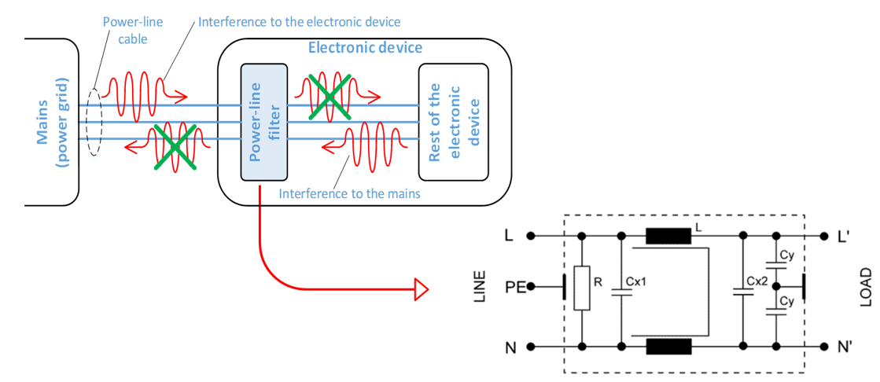
Figure 20. Power-line filter components.
Therefore, since these filter components only have effect on one of the modal components (either CM or DM), it is important to measure the modal interference components in order to build a suitable power-line filter. Thanks to the simultaneous measurement of the line and neutral terminals, EMSCOPE is able to recover and provide the measurements of the modal emissions.

7.2 Measurements According to Standards
The design philosophy behind EMSCOPE prioritizes innovation, compliance with relevant standards, and user-friendly reliability. This ensures that EMSCOPE serves as a foundational building block for any conducted emissions system, enabling the measurement and evaluation of electric or electronic devices throughout their lifecycle—from initial design stages to final certification.
The demand for precise measurement of conducted EMI noise compels equipment manufacturers to rely on dependable tools to verify compliance with applicable standards and regulations. EMSCOPE emerges as the ideal solution, offering seamless usability from prototype debugging to final certification. It delivers exceptional performance in line with industry standards while maintaining a compact, lightweight, and user-friendly design.
Its intuitive web-browser interface allows for immediate operation without requiring extensive training or specialized knowledge, enabling users to focus entirely on analyzing measurement results.
For accurate assessments, the EUT must be installed in accordance with the manufacturer’s instructions, ensuring adherence to standard operating conditions.

7.3 Measuring the EMI Voltage
ElectroMagnetic Interference (EMI) voltage measurements on power supply lines or on signal lines are carried out by means of “Coupling Networks” (e.g. LISNs) or other transducers (e.g. voltage probes). The frequency range is dictated by the applicable standard, which goes from 9 kHz to 30 MHz in most commercial applications.

7.3.1 Measuring principle with a LISN
Any LISN has three main objectives:
Important! Before using the LISN follow the provided Safety information. Not following it can result in important damages, serious injuries and death.
- To present a constant impedance to the power input of the EUT, in order to get repeatable measurements of the EUT noise present at the LISN measurement port.
- To prevent the high-frequency noise of the power source from coupling in the system. A LISN functions as a low pass filter, which provides high impedance to the outside RF noise while allowing the low-frequency power to flow through to the EUT.
- To couple the high frequency noise signal emitted by the EUT to the input of the measuring equipment (EMSCOPE receivers).
The LISN from EMSCOPE has been designed under the CISPR 16-1-2 standard for evaluating and characterizing the operation of the EUT. It is a V-type Network with an impedance of 50 Ω/50 μH + 5 Ω. The schematic of this LISN can be seen in Figure 21. It includes additional capacitors and inductors for filtering and has an operating frequency range of 9kHz to 30MHz.
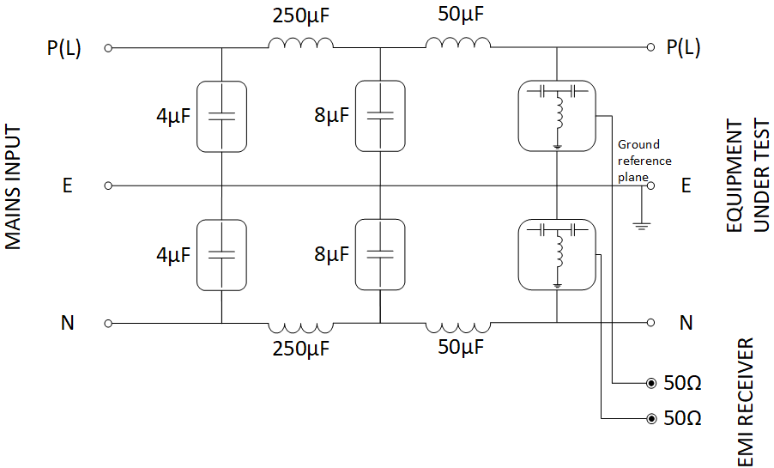
Figure 21. Schematic of the EMSCOPE’s LISN.

7.3.2 Test Setup according to CISPR 16-2-1
Figure 22 shows an example of the test setup for RFI voltage measurement according to CISPR 16-2-1. The EUT is placed on the top of a table at 0.8 m from a horizontal earthed conducting surface, and at 0.4 m from a vertical earthed conducting surface.
The LISN shall be bonded to the reference conducting surface.
A Floor standing EUT is placed 0,1 m above a horizontal earthed conducting surface of at least 2 m x 2 m in size. This size shall be exceeding by at least 0,5 m the projection of the EUT on the conducting surface.
The power cable (IEC 14 in this case) should be 1m long; longer cable should be centrally bundled for at least 40 cm.
DUTs without a PE (Protective Earth) conductor and manually operated DUTs shall be measured in conjunction with an auxiliary screen or an “Artificial Hand”, as duly specified in the relevant standards.
All the details and information on the test setup are written on the latest version of the applicable Standard.
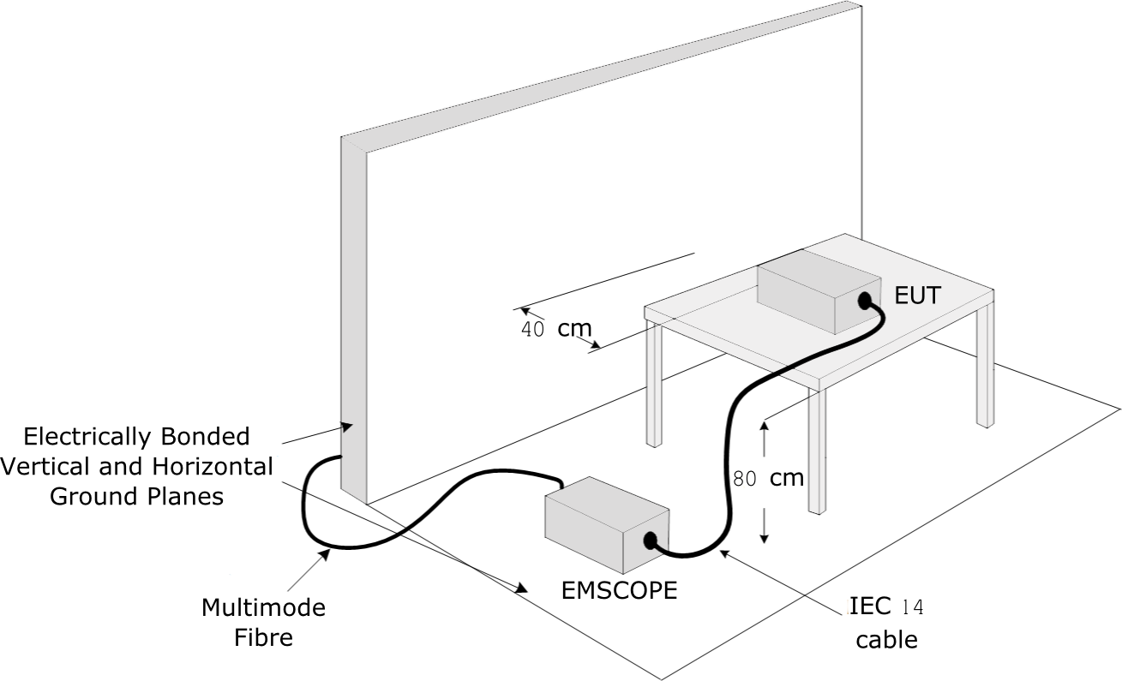
Figure 22. Test setup for RFI voltage measurement.

7.3.3 Guidance on a preliminary Measuring Procedure for Band B
A step-by-step example of a conducted test manually performed is the following:
- Switch ON the EMSCOPE and connect to it as described above.
- Introduce a Reference Level between 110 and 125 dBµV and a RBW of 9 kHz selecting the proper frequency measurement range inside the Span menu. Adjust the Scale/Div to 10 dB.
- Set the Input attenuator to Automatic mode.
- Introduce a Span between 150 kHz and 30 MHz (check the Common values option).
- Set the dwell time to 2 seconds.
- Open as many traces as detectors desired and select the suitable one in each of them (for instance, peak and average detectors).
- Select L-G or N-G measurement in each trace (if both are desired, do it in different tabs).
- Go to Standard & Report Tab and find the desired standard. If it doesn’t exist, generate a new one. After this, check Plot standard to see the limits in the measurement graphic.
- Connect the two outputs of the LISN to the two RF inputs of the EMI receiver using the N bridges.
- With the EUT switched OFF, check that the ambient RF disturbances are at least 20 dB below the desired limit of emissions. If the ambient noises are low enough continue to the next step, otherwise take all the necessary steps to reduce the ambient disturbances (e.g. go to a shielded room).
- Switch ON the EUT and wait for the measurement (the measurement time is equal to the dwell time, in this case, two seconds).
- Adjust the Dynamic Range and the Reference Level to the most convenient visualization.
- If the results are satisfactory, press the button Generate list to list the conflictive emissions.
- Press the button Generate Report to obtain an automatic report of the measurements.

7.3.4 Remarks and Hints for Measuring
To avoid errors caused by ambient interference, measurements should be carried out inside a properly shielded room. Different sites, like basements or other rooms with low ambient interference, are often enough for a preliminary evaluation.
Conducted measurements do not strictly require any anechoic environment.

8. Updating Firmware and Software
To update the firmware, access the main interface, go to “Device configuration” and click on “Update Device”; optionally type the following address in the URL field:
http://emscope-xxxx.local/update.html
where xxxx are the last 4 characters from the SN of your EMSCOPE. The SN is provided in the rear panel. A web interface similar to that shown in Figure 23 appears.
If EMSCOPE has access to https://emzer.com/, the user will be notified and prompted to update the device automatically once the user authorizes it.
If the EMSCOPE can’t reach the Internet, the user can manually download the latest firmware image from https://emzer.com/updates and upload it to the EMSCOPE by clicking on the “manual update” link and selecting the update file with the “Choose File” button.
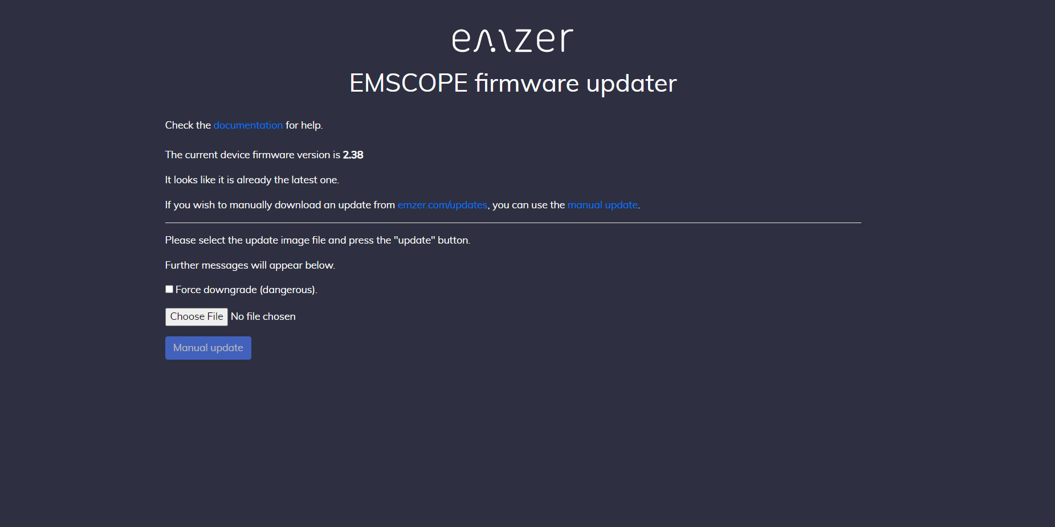
Figure 23. Web interface for an image updating.

9. Remote control
The EMSCOPE software consists in a WebSocket server listening on port 8010 of the machine, and a web server listening on the standard http port 80 that serves the frontend html and related files.
For users that want to write an application for automatic configuration and measurements, EMZER provides the WebSocket API specification (PDF), and a Javascript API that includes an implementation and example.

10. Maintenance
Maintenance of the equipment is limited to external components such as cables.
During operation, inside the equipment there are DANGEROUS voltages that could be contacted. To prevent electrical shock, do not open the equipment.
Clean the exterior of the equipment using a damp cloth and mild cleaner. Always unplug the unit before cleaning.
Product may be opened only by authorized, specially trained personnel. Before performing any work on the unit, this must be disconnected from the mains. Only technical personnel authorized by EMZER can perform any adjustments, replacement of parts or repair.

11. Disposal
This equipment is designed and manufactured with materials and components that can be recycled minimizing the environmental footprint.
A product that is labeled with a crossed-out wheeled bin symbol means it is covered by the European Directive 2012/19/EU and cannot be disposed of in normal household waste at the end of its life.

Figure 24. Label according to EU WEEE directive.
Please act according to your local rules. The correct disposal of your old products will help prevent potential negative consequences for the environment and human health.

11. Troubleshooting Guide

Problems with MDNS
To make the connection to the EMSCOPE devices as easy as possible, the protocol MDNS is used. Thanks to it, the user only needs to type the following address in the URL field for the connection:
http://emscope-xxxx.local/
where xxxx are the last 4 characters from the SN of the EMSCOPE.
In some specific scenarios, the MDNS can fail, obtaining something similar to:
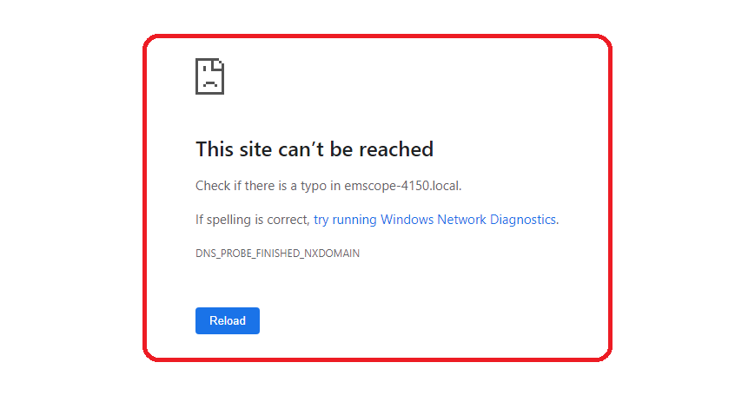
Figure 25. Web text shown when EMSCOPE is not reached.
There are multiple reasons for this behavior. To overcome this problem, please, follow the steps below:
- Check that your EMSCOPE is properly connected. The SFP Multi-mode optical fiber must be connected between the EMSCOPE's SFP connector (rear panel of the device) and the fiber to Ethernet/USB converter. The converter must be connected to a LAN or directly to the PC.
- Check that your EMSCOPE is switched on. The startup lasts approximately one minute. Once it has finished, the leftmost LED is fixed green, the center LED is flashing yellow, and the rightmost LED is fixed green as well.
If the EMSCOPE is properly connected and switched on, but it cannot be reached yet, try the following steps:
- Keeping the EMSCOPE switched on, restart the PC. Windows usually only updates the MDNS table when it starts. After restarting the PC, try to connect to the EMSCOPE using the MDNS address.
- If the previous step does not solve the connection problems, try connecting to the EMSCOPE using its IP address. For instance: http://10.30.0.171/
- If the IP address is not known, install the Bonjour software. With this software, it is possible to check if the EMSCOPE’s web service is available and, if so, which IP address it has. Then, try to connect directly using the IP address (previous step).
Having a LAN with a proxy server can be a reason to reach the EMSCOPE when using the IP but not when using the MDNS address. To overcome this problem, please read the following Section.

How to Bypass Proxy Server for Local Addresses in Windows 10
In case of using Windows 10 connected to a LAN with a proxy server, the MDNS will not work (only works directly writing the IP address of the EMSCOPE in the web browser). Windows does not exclude the local website addresses like intranet or localhost from proxy by default. To bypass the proxy, follow the steps of one of the options below:

Using Internet Options
- Press “Win + E” shortcut keys to open File Explorer.
- Type “control panel” in the address bar and press enter key to open Control Panel app.
- Change the “View by” option to “Category” to view the details.
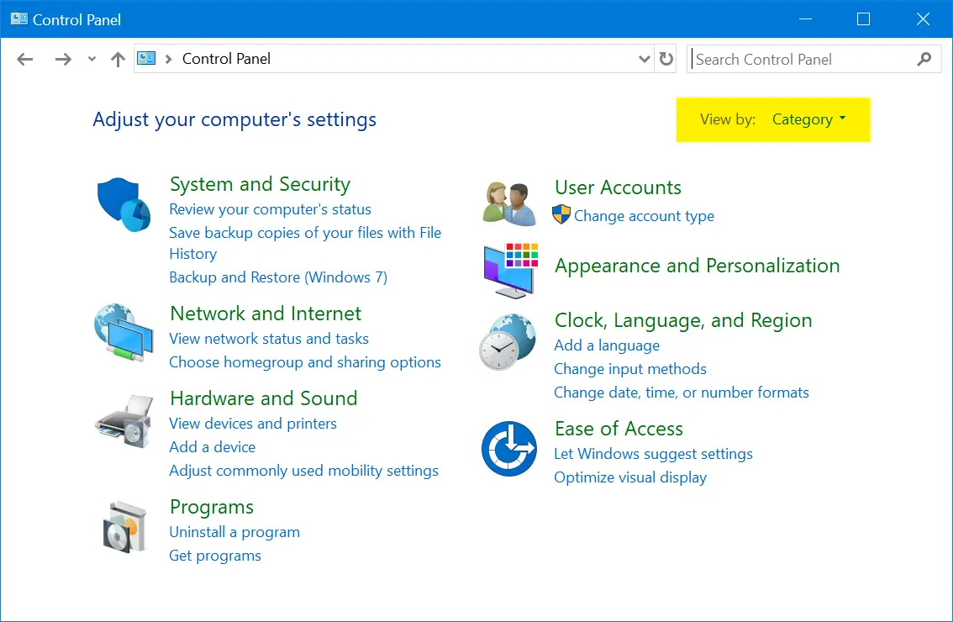
Figure 26. Control Panel Category View.
- Click on “Network and Internet” option and then click on “Internet Options”.
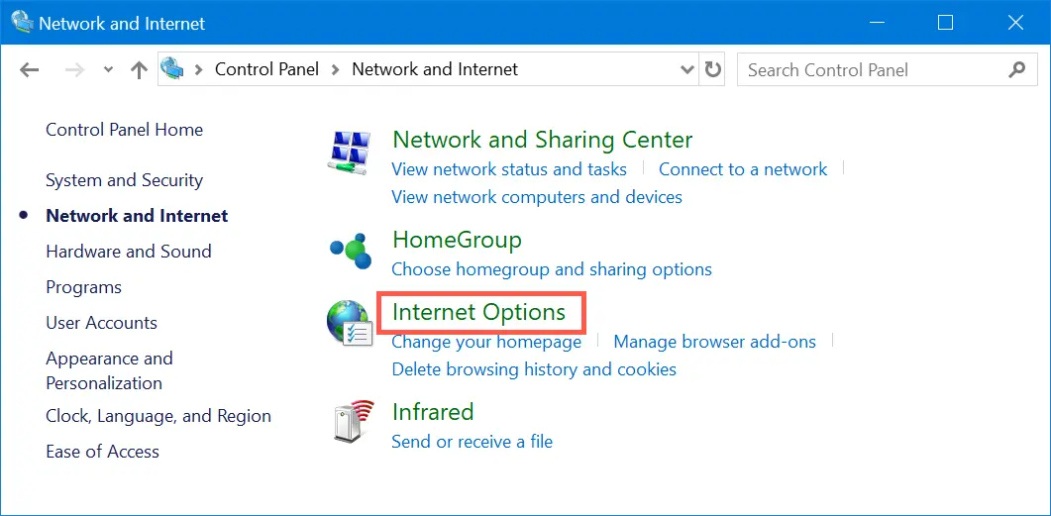
Figure 27. Open Internet Options from Control Panel.
- Alternatively, you can use Windows Search box to search “internet options” and open the Internet Properties dialog box.
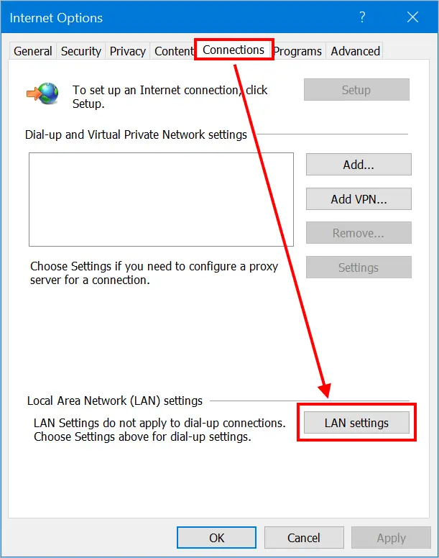
Figure 28. LAN Settings in Windows 10.
- Go to “Connections” tab and click on “LAN settings” button. This will open “Local Area Network (LAN) Settings” pop-up. Enable “Use a proxy server for your LAN” check box to enter the IP address and port of your proxy server.
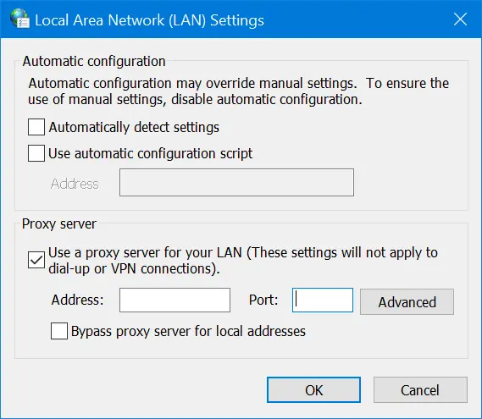
Figure 29. Setup Proxy Server in Windows 10.
- Now that you have setup a proxy server and all network from your computer will go through the proxy. For providing exception or bypassing your local intranet website addresses, enable “Bypass proxy server for local addresses” check box and click on “Advanced” button.
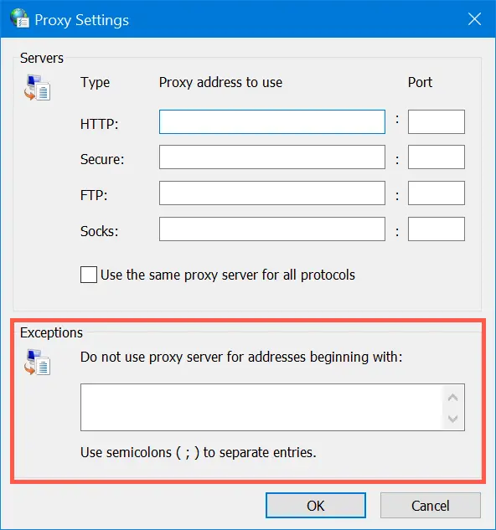
Figure 30. Provide Exceptions in Proxy.
- Under “Exceptions” box, type all the website addresses you do not want to use proxy. Use semicolon to separate each address you want to exclude. Click “OK” to apply your changes. In this case: http://emscope-xxxx.local/, or just “emscope-xxxx”.

Using Settings App
- Press “Win + I keys to open the Windows Settings app and go to “Network & Internet” section.
- Go to “Proxy” section and enable “Use a proxy server” option under “Manual proxy setup” section.
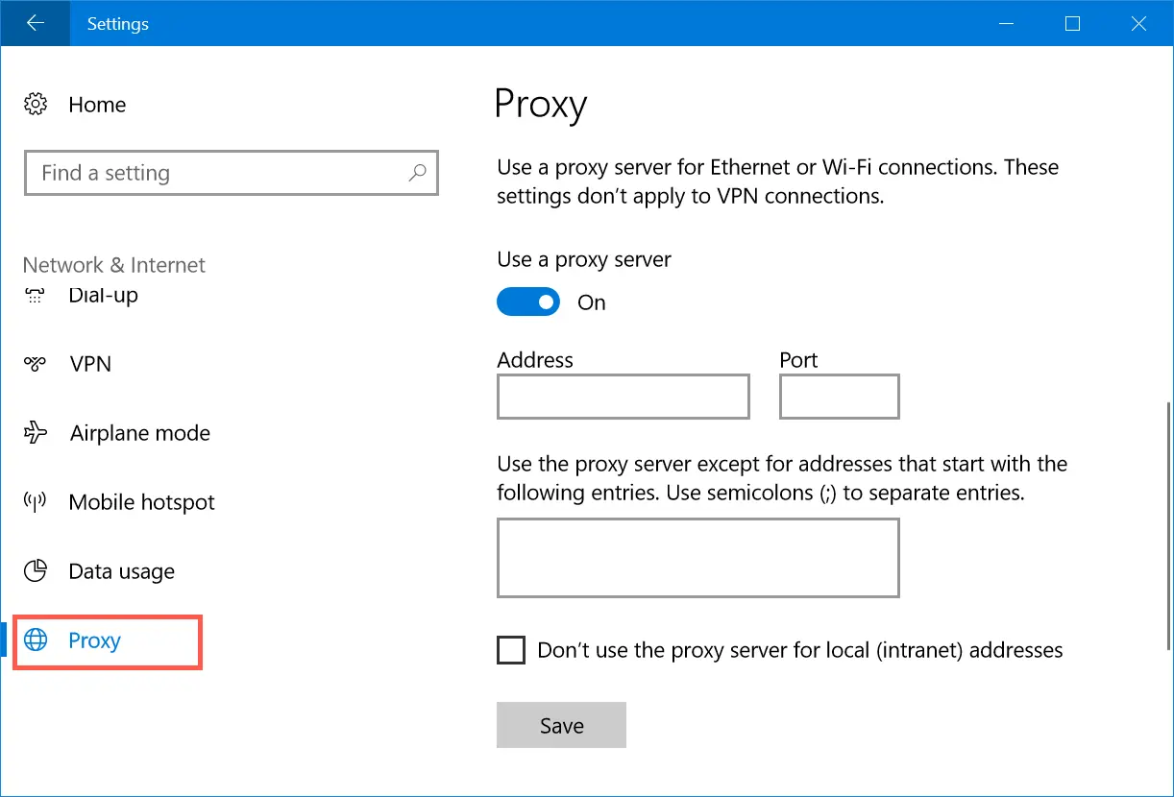
Figure 31. Manual Proxy Server Setup.
- Type the addresses in the text box to exclude them from proxy access. In this case: http://emscope-xxxx.local/, or just “emscope”.
- Enable the checkbox “Don’t use the proxy server for local (intranet) addresses” option.
- Click “Save” button to save your changes.

Using Firefox Network Settings
All the browsers like Chrome, Edge and IE use the computer’s network settings for proxy. However, Firefox has standalone browser settings that allow you to add proxy and exceptions within the browser. Remember, this method is effective only within Firefox browser and your computer’s network will still follow the default settings from Internet Options.
- Go to “about:preferences” page, scroll down to “Network Settings” and click on the “Settings…” button.
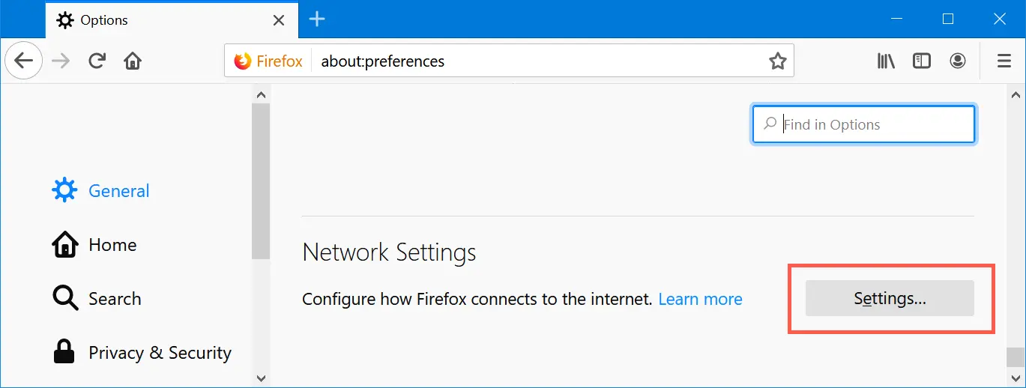
Figure 32. Firefox Network Settings.
- This will open “Connection Settings” pop-up within Firefox.
- Choose either manual or automatic proxy configuration option.
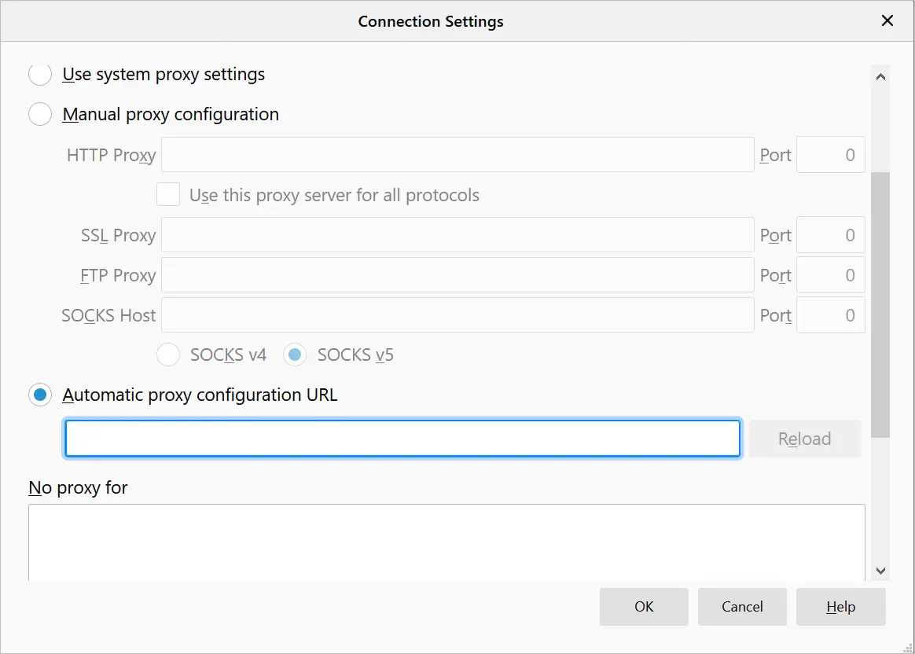
Figure 33. Setup Proxy in Mozilla Firefox.
- Type the exception for local and other website addresses under “No proxy for” text box. In this case: http://emscope-xxxx.local/, or just “emscope”.
- Click “OK” to save your changes.

Return for Repair form
Dear Customer,
Thank you for purchasing an EMZER’s product. You now own a high-quality instrument that will give you many years of reliable service. EMZER recognizes the importance of the Customer as reason of existence; in this view, any comment and suggestion you would like to submit to the attention of our service organization is kept in great consideration. Moreover, we are continuously improving our quality, but we know this is a never-ending process. We would be glad if our present efforts are pleasing you. Should one of your pieces of EMZER equipment need servicing you can help us serve you more effectively filling out this card and enclosing it with the product. Nevertheless, even this product will eventually become obsolete. When that time comes, please remember that electronic equipment must be disposed of in accordance with local regulations. This product conforms to the WEEE Directive of the European Union (2002/96/EC) and belongs to Category 9 (Monitoring and Control Instruments). You can return the instrument to us free of charge for proper environment friendly disposal. You can obtain further information from your local EMZER Sales Partner or by visiting our website at www.emzer.com.
Service needed
- Calibration only
- Repair
- Repair & Calibration
- Certified Calibration
- Other
Company:
Address:
Technical contact person:
Phone number:
Equipment Model:
Serial Number:
Accessories returned with unit:
- None
- Cable(s)
- Power cable
- Other:
Observed symptoms/problems:

