LIZN User’s Manual

1. General Information

1.1 Documentation
Enclosed with this manual are:
- a service questionnaire to send back to EMZER in case an equipment service is needed (end)
- an accessories checklist to verify all accessories enclosed in the packaging.

1.2 Introduction to LIZN
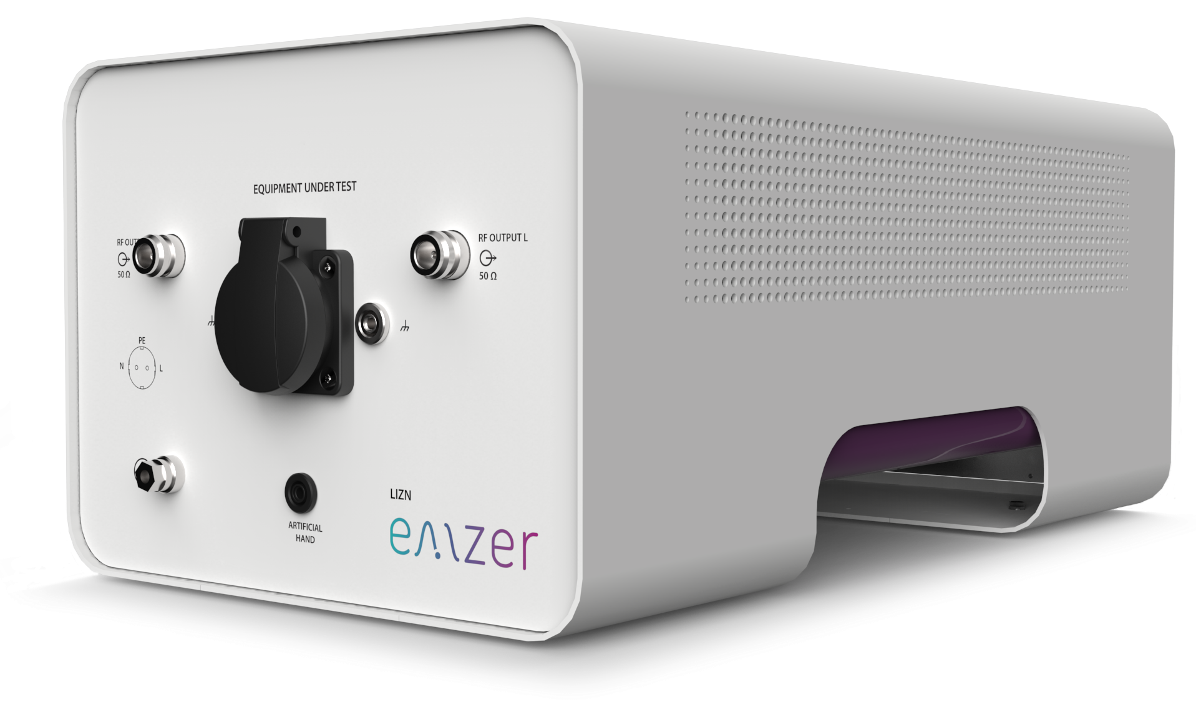
Figure 1. LIZN picture.
LIZN is the new EMZER’s 16-A single-phase dual-port V-network Line Impedance Stabilization Network (LISN) that has been optimally designed and manufactured to be compliant to CISPR 16-1-2 International Standard for the measurements of the conducted electromagnetic interference.
The LIZN impedance is (50µH+5Ω) ⁄⁄ 50Ω and can be operated in the frequency range from 9 kHz to 30 MHz. An artificial hand connector is provided at the front panel with an impedance of 510Ω + 220pF (as described in CISPR 16-1-2), along with several ground connectors in both front and rear panels (including a large grounding bar) to facilitate its assembly to the complex EMC-test setup. The instrument is equipped with a high-performance 250-µH inductor that provides an excellent decoupling between the device under test and the mains, filtering any external interference voltage. The internal circuit is completed with a 5-kHz high-pass filter that provides a flat response above the 9 kHz.
The LIZN can be used for AC and DC measurements. The two N-type connectors provided in the front panel allow the simultaneous measurement of line and neutral conducted emissions, which facilitates the obtention of the common-mode and differential-mode (modal) conducted emissions. Modal emission measurements, that can be performed using a two-port oscilloscope or a vector analyser, are fundamental to know the dominant mode and to implement the suitable power-line filter accordingly, using fewer components and getting a cheaper design.
Important! Before using the LISN, all safety requirements must be fulfilled.

1.3 Instrument Items
The packaging list includes the following items:
- LIZN enclosure containing a 16-A single-phase dual-port V-network LISN.
- IEC 20 cable.
- A 50-Ω N-connector load.

1.4 Main Specifications
Table 1-1 lists the LIZN performance specifications. The following conditions apply to all specifications:
Table 1-1 Main Specifications of the EMI Receiver
Electrical Characteristic | Performance Limits
Standard | Fully compliant to CISPR 16-1-2 and MIL-STD-461 standards
Frequency range | 9 kHz to 30 MHz
CISPR equivalent circuit / Pre-filter Choke | 50 Ω / / (50 μH + 5 Ω) / 250 μH
Continuous rated output current | 16 A @230AC (socket dependent)*
Max permissible operating voltage | 300 VAC – 325 VDC (socket dependent)*
EUT supply frequency range | DC to 60 Hz
RF connector type | 2 ports N female
EUT Power connector / mains | Schuko socket (Type F) / IEC C20
Artificial Hand / connector type | 510 Ω + 220 pF / 4 mm socket
Dimensions (W x H x D) | 252 x 195 x 438 mm
Weight | 7.5 kg
* Examples of sockets:
- NEMA 5-15R: 15A / 125Vac
- EU Type F: 16A / 230Vac
- GB BS1363 Type G: 13A / 250Vac

1.5 Front Panel
The front panel of the LIZN is shown in the next figure.
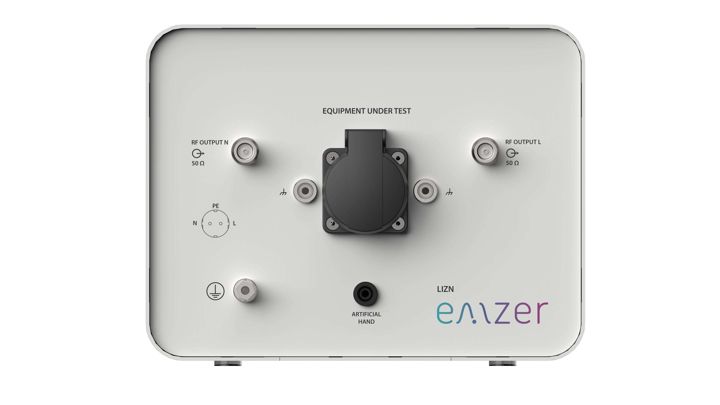
Figure 2. Front panel.
Connectors and indicators of the front panel from top to bottom:
- RF output connectors
The equipment has 2 N female RF output connectors. Each connector is the output of a channel of the artificial mains network (LISN). These connectors output the conducted interferences generated by the equipment under test and provide the means to measure them.
- Output mains power network supply socket
This socket is the output of the artificial mains power network of the LISN. It is the mains socket where the equipment under test must be connected to allow the measurement of its conducted emissions. The technical specifications of the LISN and its power handling capabilities are described under the Main Specifications section.
- Artificial Hand 4mm socket
This socket provides the RC network required to mimic the behaviour of a hand for a handheld equipment under test, as stated in the CISPR 16-1-2. This RC network is described in the Main Specifications section.
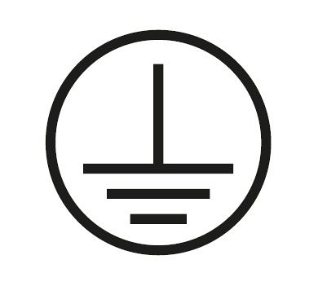
- Protective Earth terminal. It is a M6 threaded bolt for connecting the protective earth conductor.
- Additionally, there exist two 4mm female sockets for connecting the reference ground during calibration.

1.6 Rear Panel
The rear panel of the equipment is shown in the next figure:
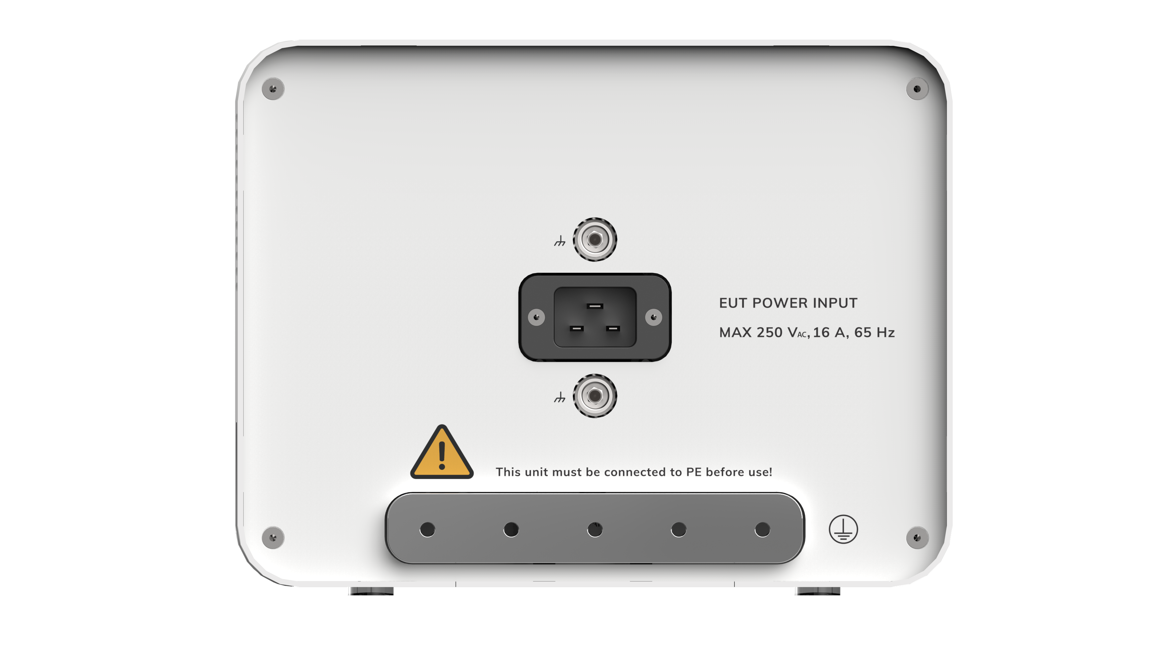
Figure 3. Rear panel.
Connectors of the rear panel from top to bottom:
- IEC-20 socket. It is the socket of the mains power supply that cross the LISN and feeds device under test.
- Grounding bar. This bar provides an appropriate RF ground reference and it should be connected to the grounded RF plane as described in different standards ( e.g. CISPR 16-2-1).
- Additionally, there exist two 4mm female sockets for connecting the reference ground during calibration.

2. Safety information

2.1 General safety information
Never remove the cover or any part of the housing. During operation, there exists accesible parts with DANGEROUS voltages inside the unit.
Do not insert any objects into the openings of the housing that are not intended to that purpose. This can cause short circuits inside or electric shocks/injuries.
The unit is not protected agains the penetration of liquids.
Do not close any of the openings needed for ventilation.
Since the ventilation air flows from the botton side, the unit must be placed on a nonflammable base in order to prevent a fire in case of overheating.

2.2 Safety information regarding the Line Impedance Stabilization Network (LISN)
Important! Over current protection is not provided. The LISN must be connected to a power mains which has an appropiately rated mains protection installed.
Important! Before putting into service ensure that:
- An additional PE conductor is connected (see next paragraph)
- The ventilation openings are unobstructed
Important! Earth connection: Precautions must be taken because, since the LISN is compliant to CISPR 16, it can not inherently adhere to the permitted leakage current limit value according to EN 61010-1 and basic insulation of a protection class I. Due to this inherent high leakage current to ground of this kind of equipment an additional protective earth connection must be supplied prior connecting the unit to the mains power supply. For this purpose, the equipment is provided with an earth grounding bar at the rear panel and additionally a protective earth screw is provided at the front.
Important! In addition, due to this high leakage current (above 1 A), it is not possible to use a residual current operated circuit breaker. It is strongly recommended to use an isolating transformer.
Important! A long-term operation with maximum load, the surface of the unit may become >60 ºC.

3. Installation

3.1 Introduction
This section provides the information needed to install your LIZN. It includes the information pertinent to initial inspection and power requirements, connections, operating environment, instrument mounting, cleaning, storage and shipment.
Important! Before connecting the equipment follow the provided Safety information section. Not following it can result in important damages, serious injuries and death.

3.2 Initial Inspection
When receiving the equipment, first inspect the shipping box for any damages. If the shipping box is damaged, it should be kept until the contents of the shipment have been checked for completeness and the instrument has been checked mechanically and electrically.

3.3 Packing and Unpacking
Verify the availability of all the shipped items with reference to the shipping check list indicated in this User Manual. Notify any damage to the forwarder personnel as well as to your EMZER Representative.
To avoid further damage, do not use the instrument when there are signs of shipping damage to any portion of it.

3.4 Preparation for Use
The LIZN is equipped with protective/functional earth terminals on the rear and front panels. A good safety/functional ground connection should be provided before to operating the system.
Important! Since the LISN is constructed according to the CISPR 16 standard, it can NOT comply with the permissible leakage current limit stated in the IEC 61010 for a class I equipment. The instructions provided in the Safety Information section must be followed.

3.5 Environment
The operating environment of the receiver is specified to be within the following limits:
- Temperature : 0 °C to +40 °C
- Humidity : < 85% relative;
- Altitude : 3000 meters
The instrument should be stored and shipped in a clean, dry environment which is specified to be within the following limitations:
- Temperature : -40 °C to +50 °C (-40 °C to +40 °C for long periods)
- Humidity : < 95% relative (< 80% relative for long periods)
- Altitude : 15000 meters

3.6 Return for Service
If the instrument should be returned to EMZER for service, please complete the service questionnaire enclosed with the User Manual and attach it to the instrument.
To minimize the repair time, be as specific as possible when describing the failure. If the failure only occurs under certain conditions, explain how to duplicate the failure.
If possible, reusing of the original packaging to ship the equipment is preferable.
In case other package should be used, ensure to wrap the instrument in heavy paper or plastic.
Use a strong shipping box and use enough shock absorbing material all around the equipment to provide a firm cushion and prevent movement in the shipping box; in particular protect the front panel.
Seal the shipping box securely.
Mark the shipping box FRAGILE to encourage careful handling.

3.7 Equipment Cleaning
Use a clean, dry, non-abrasive cloth for external cleaning of the equipment.
To clean the equipment do not use any solvent, thinner, turpentine, acid, acetone or similar matter to avoid damage to external plastic or display surfaces.

3.8 Equipment Ventilation
To allow correct equipment ventilation, ensure that the vent grids on the side and on the bottom of the equipment are free by any obstructing object.

3.9 Using the Line Impedance Stabilization Network (LISN)
Important! Before using the LIZN's built-in LISN, follow the provided Safety information. Not following it can result in important damages, serious injuries and death.
LIZN must be bonded to the Protective Earth (PE) using the grounding bar placed in the rear panel.
In order to avoid the unwanted tripping of the protection devices (due to the high leakage current inherently present in the LISN due to its construction made according to CISPR 16-1-2), an insulation transformer shall always be used between the mains supply and the LISN.

4. LIZN calibration

4.1 Typical measured curves
Impedance, magnitude:
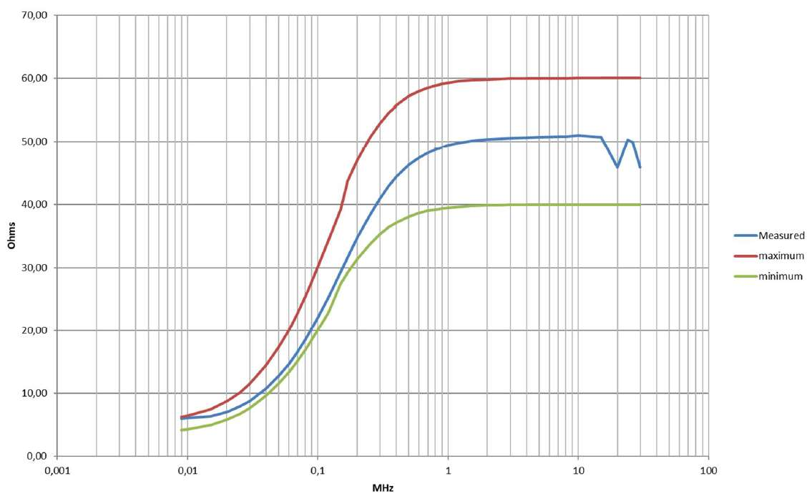
Figure 4. Impedance, magnitude.
Impedance, phase:
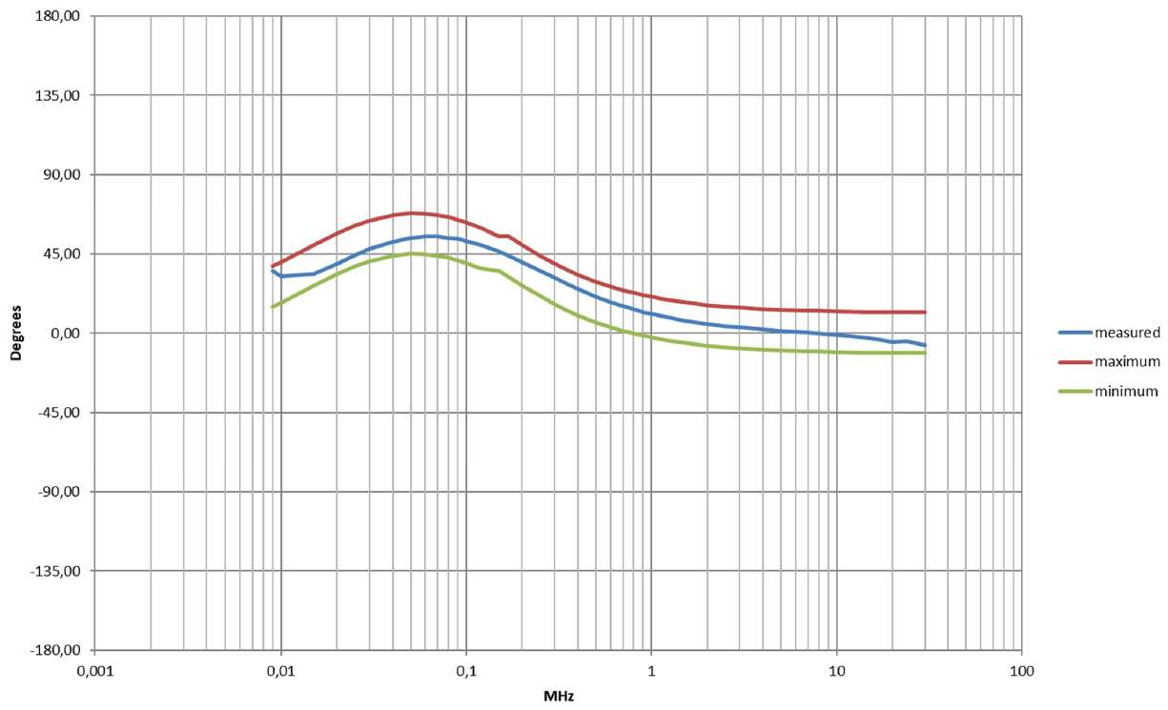
Figure 5. Impedance, phase.
Voltage Division Factor (external 10dB att. included):
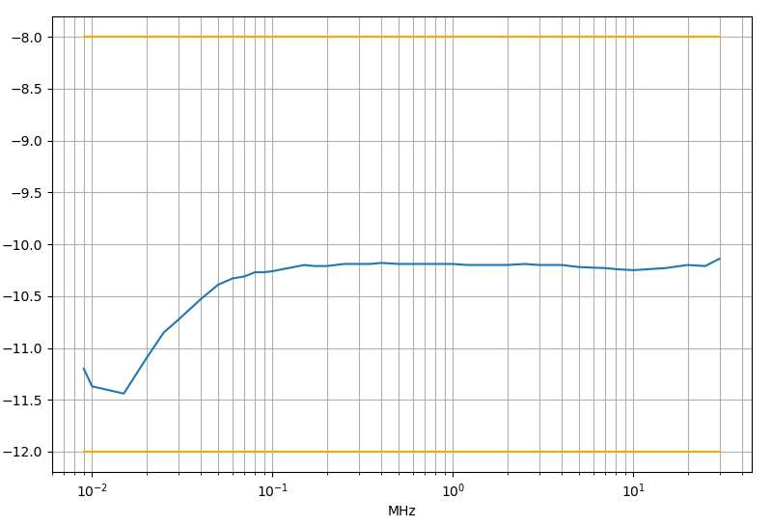
Figure 6. Voltage Division Factor.
Isolation between mains port and RF port:
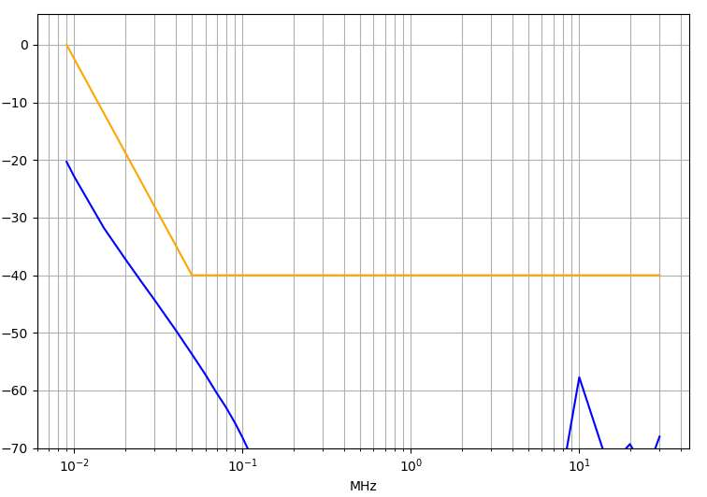
Figure 7. Isolation between mains port and RF port.

5. Applications

5.1 Measuring the EMI Voltage
ElectroMagnetic Interference (EMI) voltage measurements on power supply lines or on signal lines are carried out by means of “Coupling Networks” (e.g. LISNs) or other transducers (e.g. voltage probes). The frequency range is dictated by the applicable standard, which goes from 9 kHz to 30 MHz in most commercial applications.

5.1.1 Measuring principle with a LISN
Important! Before using the LISN follow the provided Safety information. Not following it can result in important damages, serious injuries and death.
Any LISN has three main objectives:
- To present a constant impedance to the power input of the EUT, in order to get repeatable measurements of the EUT noise present at the LISN measurement port.
- To prevent the high-frequency noise of the power source from coupling in the system. A LISN functions as a low pass filter, which provides high impedance to the outside RF noise while allowing the low-frequency power to flow through to the EUT.
- To couple the high frequency noise signal emitted by the EUT to the input of the measuring equipment (EMI receiver/spectrum analyzer/oscilloscope).
The LISN from LIZN has been designed under the CISPR 16-1-2 standard for evaluating and characterizing the operation of the EUT. It is a V-type Network with an impedance of 50 Ω/50 μH + 5 Ω. The schematic of this LISN can be seen in Figure 9. It includes additional capacitors and inductors for filtering and has an operating frequency range of 9kHz to 30MHz.
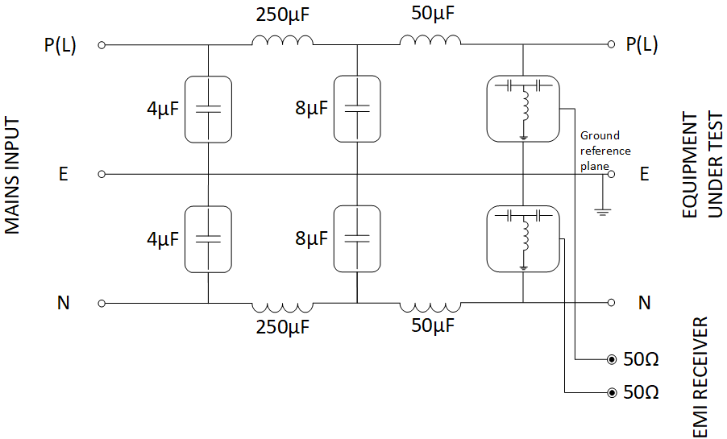
Figure 8. Schematic of the LIZN’s LISN.

5.1.2 Test Setup according to CISPR 16-2-1
Figure 10 shows an example of the test setup for RFI voltage measurement according to CISPR 16-2-1. The EUT is placed on the top of a table at 0.8 m from a horizontal earthed conducting surface, and at 0.4 m from a vertical earthed conducting surface.
The LISN shall be bonded to the reference conducting surface.
A Floor standing EUT is placed 0,1 m above a horizontal earthed conducting surface of at least 2 m x 2 m in size. This size shall be exceeding by at least 0,5 m the projection of the EUT on the conducting surface.
The power cable (IEC 14 in this case) should be 1m long; longer cable should be centrally bundled for at least 40 cm.
DUTs without a PE (Protective Earth) conductor and manually operated DUTs shall be measured in conjunction with an auxiliary screen or an “Artificial Hand”, as duly specified in the relevant standards.
All the details and information on the test setup are written on the latest version of the applicable Standard.
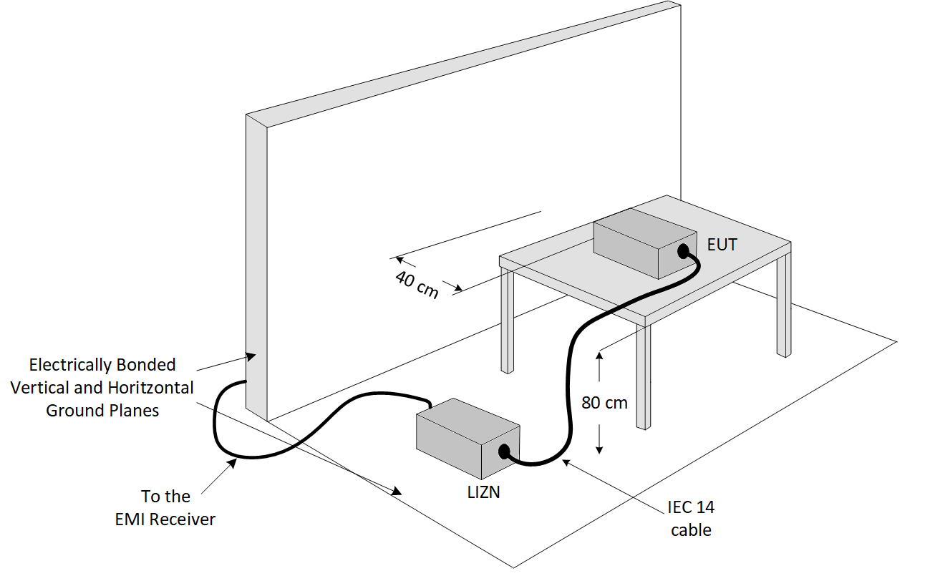
Figure 9. Test setup for RFI voltage measurement.

5.1.3 Remarks and Hints for Measuring
To avoid errors caused by ambient interference, measurements should be carried out inside a properly shielded room. Different sites, like basements or other rooms with low ambient interference, are often enough for a preliminary evaluation.
Conducted measurements do not strictly require any anechoic environment.

6. Maintenance
Maintenance of the equipment is limited to external components such as cables.
During operation, inside the equipment there are DANGEROUS voltages that could be contacted. To prevent electrical shock, do not open the equipment.
Clean the exterior of the equipment using a damp cloth and mild cleaner. Always unplug the unit before cleaning.
Product may be opened only by authorized, specially trained personnel. Before performing any work on the unit, this must be disconnected from the mains. Only technical personnel authorized by EMZER can perform any adjustments, replacement of parts or repair.

7. Disposal
This equipment is designed and manufactured with materials and components that can be recycled minimizing the environmental footprint.
A product that is labeled with a crossed-out wheeled bin symbol means it is covered by the European Directive 2012/19/EU and cannot be disposed of in normal household waste at the end of its life.

Figure 10. Label according to EU WEEE directive.
Please act according to your local rules. The correct disposal of your old products will help prevent potential negative consequences for the environment and human health.

Service Questionnaire
Dear Customer,
Thank you for purchasing an EMZER’s product. You now own a high-quality instrument that will give you many years of reliable service. EMZER recognizes the importance of the Customer as reason of existence; in this view, any comment and suggestion you would like to submit to the attention of our service organization is kept in great consideration. Moreover, we are continuously improving our quality, but we know this is a never-ending process. We would be glad if our present efforts are pleasing you. Should one of your pieces of EMZER equipment need servicing you can help us serve you more effectively filling out this card and enclosing it with the product. Nevertheless, even this product will eventually become obsolete. When that time comes, please remember that electronic equipment must be disposed of in accordance with local regulations. This product conforms to the WEEE Directive of the European Union (2002/96/EC) and belongs to Category 9 (Monitoring and Control Instruments). You can return the instrument to us free of charge for proper environment friendly disposal. You can obtain further information from your local EMZER Sales Partner or by visiting our website at www.emzer.com.
Service needed
- Unordered List Item
- Calibration only
- Repair
- Repair & Calibration
- Certified Calibration
- Other
Company:
Address:
Technical contact person:
Phone number:
Equipment Model:
Serial Number:
Accessories returned with unit:
- None
- Cable(s)
- Power cable
- Other:
Observed symptoms/problems:

